CODING

NEW USER DETAILS

import java.awt.*;
import java.awt.event.*;
import java.sql.*;
import javax.swing.*;

class Frame1 extends Frame implements ActionListener,WindowListener
{
Label l1=new Label("New User Details");
Label l2=new Label("User Name -");
Label l3=new Label("Password -");
Label l4=new Label("Confirm Password -");
Label l5=new Label("Secret Qusetion -");
Label l6=new Label("Answer -");
TextField t1=new TextField("");
TextField t2=new TextField("");
TextField t3=new TextField("");
TextField t4=new TextField("");
Choice ch=new Choice();
Button b1=new Button("Create");
Button b2=new Button("Cancel");
Font ft=new Font("Arial",Font.BOLD,20);
Font ft1=new Font("Arial",Font.BOLD,15);
Connection con;
PreparedStatement st;
ResultSet rs;
String un,pass,cpass,sq,answ,user;

Frame1()
{
setSize(520,550);
setLocationRelativeTo(null);
setLayout(null);
setResizable(false);
addWindowListener(this);

l1.setBounds(130,40,200,50);add(l1);
l1.setFont(ft);

l2.setBounds(50,110,100,30);add(l2);
l2.setFont(ft1);

l3.setBounds(50,180,100,30);add(l3);
l3.setFont(ft1);

l4.setBounds(50,240,130,30);add(l4);
l4.setFont(ft1);

l5.setBounds(50,300,130,30);add(l5);
l5.setFont(ft1);

l6.setBounds(50,360,100,30);add(l6);
l6.setFont(ft1);

t1.setBounds(260,110,200,30);add(t1);
t1.setFont(ft1);

t2.setBounds(260,180,200,30);add(t2);
t2.setEchoChar('*');
t2.setFont(ft1);

t3.setBounds(260,240,200,30);add(t3);
t3.setEchoChar('*');
t3.setFont(ft1);

t4.setBounds(260,360,200,30);add(t4);
t4.setFont(ft1);
t4.setEchoChar('*');

ch.setBounds(260,300,200,30);add(ch);
ch.add("What is your birth place");
ch.add("What is your pet name");
ch.add("What is your first school name");
ch.add("What is your nationality");
ch.setFont(ft1);

b1.setBounds(80,450,100,40);add(b1);
b1.addActionListener(this);
b1.setFont(ft1);

b2.setBounds(280,450,100,40);add(b2);
b2.setFont(ft1);
b2.addActionListener(this);

try
{
Class.forName("com.mysql.jdbc.Driver");
con=DriverManager.getConnection("jdbc:mysql://localhost/bca","root","");
}
catch(Exception e)
{
System.out.print(e);
}
}

public void windowOpened(WindowEvent we)
{
}

public void windowActivated(WindowEvent we)
{
}

public void windowDeactivated(WindowEvent we)
{
}

public void windowIconified(WindowEvent we)
{
}

public void windowDeiconified(WindowEvent we)
{
}

public void windowClosing(WindowEvent we)
{
dispose();
}

public void windowClosed(WindowEvent we)
{
}

public void actionPerformed(ActionEvent ae)
{
if(ae.getSource()==b1)
{
un=t1.getText();
pass=t2.getText();
cpass=t3.getText();
sq=ch.getSelectedItem();
answ=t4.getText();

try
{
st=con.prepareStatement("select * from logon where uname=?");
st.setString(1,un);
rs=st.executeQuery();

if(rs.next())
{
JOptionPane.showMessageDialog(null,"Already exist User Name");
t1.setText("");
t1.requestFocus();
}
else
{
try
{
st=con.prepareStatement("insert into logon values(?,?,?,?,?)");
st.setString(1,un);
st.setString(2,pass);
st.setString(3,cpass);
st.setString(4,sq);
st.setString(5,answ);

if(pass.equals(cpass))
{
st.executeUpdate();
JOptionPane.showMessageDialog(null,"Create Account Successfully");
t1.setText("");
t2.setText("ar");
t2.setText("");
t3.setText("");
t4.setText("");
ch.select(0);
t1.requestFocus();
}
else
{
JOptionPane.showMessageDialog(null,"password does not match");
t2.setText("ar");
t2.setText("");
t3.setText("aw");
t3.setText("");
t2.requestFocus();
}
}
catch(Exception e)
{
System.out.print(e);
}
}
}
catch(Exception e)
{
System.out.print(e);
}
}

else if(ae.getSource()==b2)
{
System.exit(0);
}
}
}

class NewUser
{
public static void main(String[] args)
{
Frame1 f=new Frame1();
f.setVisible(true);
}
}
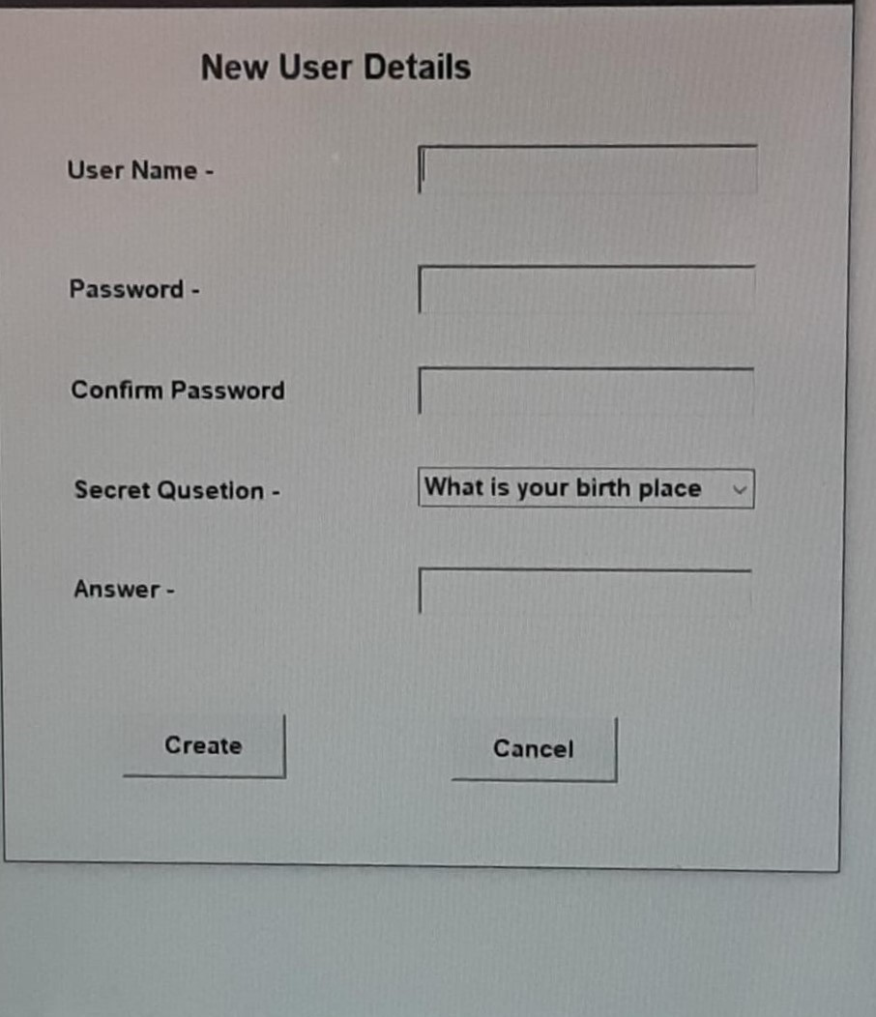
LOGIN
import java.awt.*;
import java.awt.event.*;
import java.sql.*;
import javax.swing.*;

class Frame1 extends Frame implements Action Listener, Window Listener,Mouse Listener
{
Label l1=new Label("User Name-");
Label l2=new Label("Password-");
Label l3=new Label("Forget password.");
TextField t1=new TextField();
TextField t2=new TextField();
Button b1=new Button("Submit");
Button b2=new Button("Reset");
Font ft=new Font("Arial",Font.BOLD,20);
Font fn=new Font("Arial",Font.BOLD,14);

Connection con;
PreparedStatement st;
ResultSet rs;

Frame1()
{
setTitle("Login");
setSize(420,400);
setLocationRelativeTo(null);
setLayout(null);
setResizable(false);

l1.setBounds(50,70,120,30);add(l1);
l1.setFont(ft);

t1.setBounds(230,70,150,30);add(t1);
t1.setFont(fn);

l2.setBounds(50,150,100,30);add(l2);
l2.setFont(ft);

t2.setBounds(230,150,150,30);add(t2);
t2.setEchoChar('*');
t2.setFont(fn);

b1.setBounds(80,260,80,40);add(b1);
b1.addActionListener(this);
b1.setFont(ft);

b2.setBounds(230,260,80,40);add(b2);
b2.addActionListener(this);
b2.setFont(ft);

l3.setBounds(150,320,100,30);add(l3);
l3.addMouseListener(this);

try
{
Class.forName("com.mysql.jdbc.Driver");
con=DriverManager.getConnection("jdbc:mysql://localhost/stockzz","root","tangu");
}
catch(Exception e)
{
System.out.print(e);
}
}

public void windowOpened(WindowEvent we)
{
}

public void windowActivated(WindowEvent we)
{
}

public void windowDeactivated(WindowEvent we)
{
}

public void windowIconified(WindowEvent we)
{
}

public void windowDeiconified(WindowEvent we)
{
}

public void windowClosing(WindowEvent we)
{
dispose();
}

public void windowClosed(WindowEvent we)
{
}

public void mouseClicked(MouseEvent we)
{
Frame f2=new Frame2();
f2.setVisible(true);
dispose();
}

public void mouseEntered(MouseEvent we)
{
}

public void mouseExited(MouseEvent we)
{
}

public void mousePressed(MouseEvent we)
{
}

public void mouseReleased(MouseEvent we)
{
}

public void actionPerformed(ActionEvent ae)
{
if(ae.getSource()==b1)
{
String un,pwd;
un=t1.getText();
pwd=t2.getText();

try
{
st=con.prepareStatement("select * from logon where uname=? and password=?");
st.setString(1,un);
st.setString(2,pwd);
rs=st.executeQuery();
if(rs.next())
{
}
else
{
JOptionPane.showMessageDialog(null,"Invalid Username/Password");
t1.setText("");
t2.setText("uyf");
t2.setText("");
t1.requestFocus();
}
}
catch(Exception e)
{
System.out.print(e);
}
}
else if(ae.getSource()==b2)
{
t1.setText("");
t2.setText("uyf");
t2.setText("");

t1.requestFocus();
}
}
}

class Login
{
public static void main(String[] args)
{
Frame1 f1=new Frame1();
f1.setVisible(true);
}
}

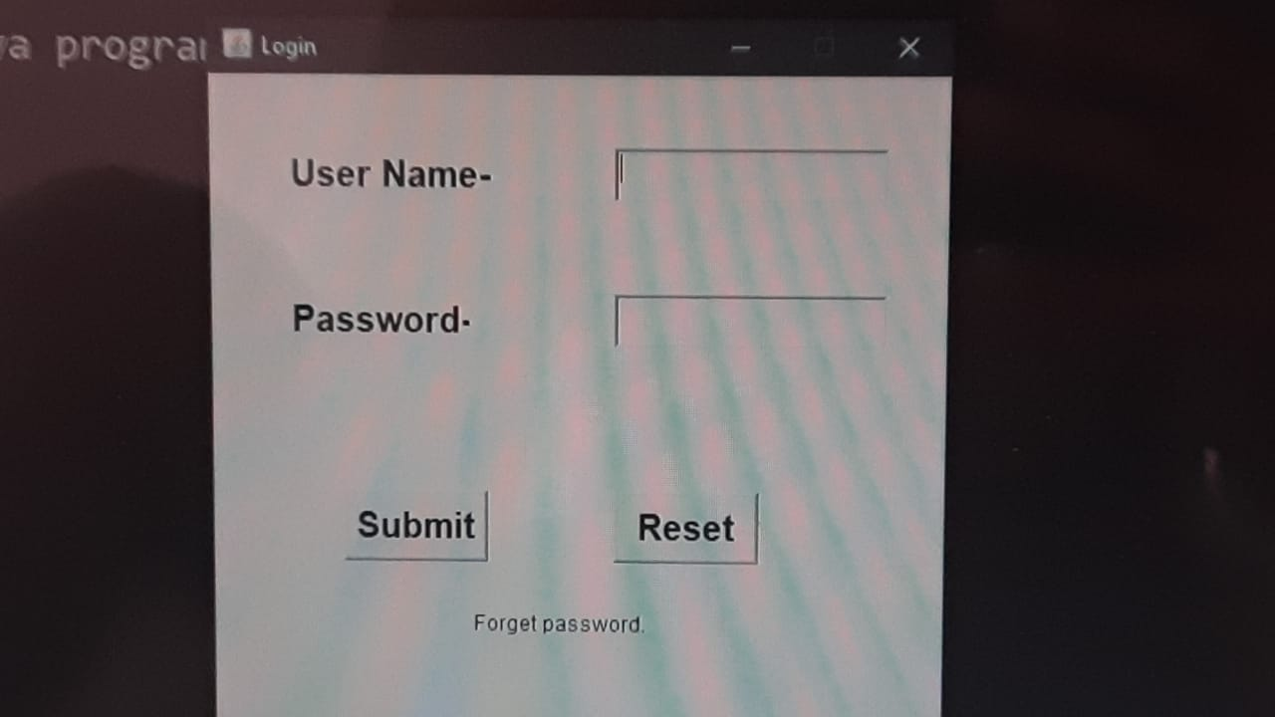
FORGET PASSWORD
import java.awt.*;
import java.awt.event.*;
import java.sql.*;
import javax.swing.*;

class Frame2 extends Frame implements WindowListener,ActionListener
{
Label l1=new Label("Forget Password");
Label l2=new Label("Security Question:-");
Label l3=new Label("Answer:-");
Label l4=new Label("User Name:-");
TextField t2=new TextField();
TextField t3=new TextField();
Choice ch=new Choice();
Button b1=new Button("Submit");
Button b2=new Button("Cancel");
Font ft=new Font("Arial",Font.BOLD,20);
Font ft1=new Font("Arial",Font.BOLD,15);
Connection con;
PreparedStatement st;
ResultSet rs;
String sq,ans,un,pwd,user;

Frame2()
{
setSize(450,400);
setLocationRelativeTo(null);
setResizable(false);
setLayout(null);
addWindowListener(this);

l1.setBounds(120,30,180,30);add(l1);
l1.setFont(ft);

l2.setBounds(30,90,150,30);add(l2);
l2.setFont(ft1);

ch.setBounds(200,90,220,40);add(ch);
ch.setFont(ft1);
ch.add("What is your birth place");
ch.add("What is your pet name");
ch.add("What is your first school name");
ch.add("What is your nationality");

l3.setBounds(30,150,120,30);add(l3);
l3.setFont(ft1);

t2.setBounds(200,150,150,30);add(t2);
t2.setFont(ft1);

l4.setBounds(30,210,120,30);add(l4);
l4.setFont(ft1);

t3.setBounds(200,210,150,30);add(t3);
t3.setFont(ft1);

b1.setBounds(80,290,100,30);add(b1);
b1.addActionListener(this);
b1.setFont(ft1);

b2.setBounds(240,290,100,30 );add(b2);
b2.setFont(ft1);
b2.addActionListener(this);

try
{
Class.forName("com.mysql.jdbc.Driver");
con=DriverManager.getConnection("jdbc:mysql://localhost/stockzz","root","tangu");
}
catch(Exception e)
{
System.out.print(e);
}
}

public void windowOpened(WindowEvent we)
{
}

public void windowActivated(WindowEvent we)
{
}

public void windowDeactivated(WindowEvent we)
{
}

public void windowIconified(WindowEvent we)
{
}

public void windowDeiconified(WindowEvent we)
{
}

public void windowClosing(WindowEvent we)
{
dispose();
}

public void windowClosed(WindowEvent we)
{
}

public void actionPerformed(ActionEvent ae)
{
if(ae.getSource()==b2)
{
System.exit(0);
}

else if(ae.getSource()==b1)
{
sq=ch.getSelectedItem();
ans=t2.getText();
user=t3.getText();

try
{
st=con.prepareStatement("select * from logon where sques=? and ans=? and uname=? ");
st.setString(1,sq);
st.setString(2,ans);
st.setString(3,user);

rs=st.executeQuery();
if(rs.next())
{
un=rs.getString(1);
pwd=rs.getString(2);
JOptionPane.showMessageDialog(null,"User Name:" + un + "\n Password:" + pwd);
dispose();
}
else
{
JOptionPane.showMessageDialog(null,"Wrong Security Question / Answer");
t2.setText("");
t3.setText("");
ch.select(0);
}
}
catch(Exception e)
{
System.out.print(e);
}
}
}
}

class Forget
{
public static void main(String[] args)
{
Frame2 f2=new Frame2();
f2.setVisible(true);
}
}
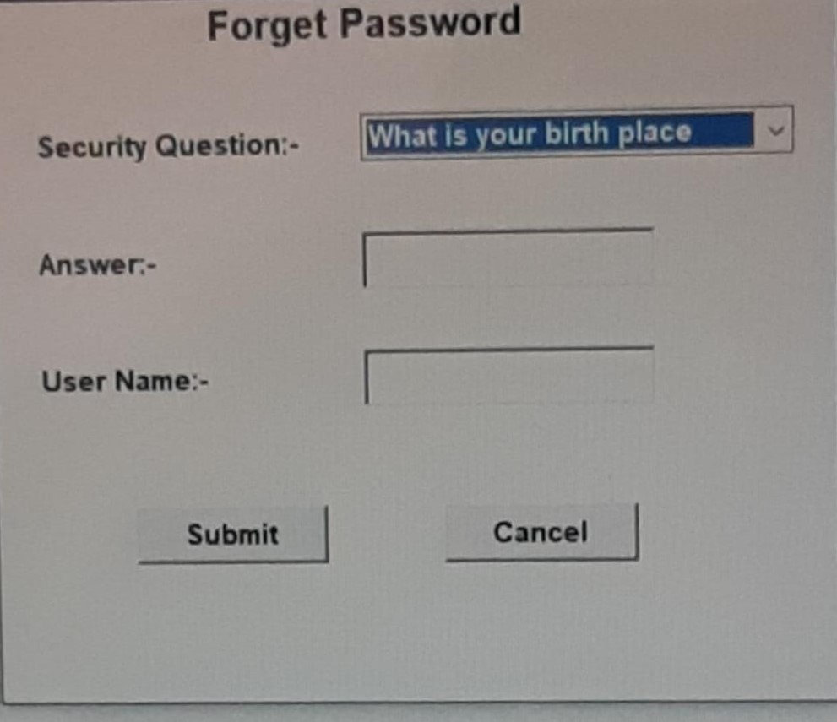
CHANGE PASSWORD

import java.awt.*;
import java.awt.event.*;
import javax.swing.*;
import java.sql.*;
class Frame1 extends Frame implements ActionListener
{
Label jl=new Label("CHANGE PASSWORD");
Label l1=new Label("User_Name");
Label l2=new Label("Old_Password");
Label l3=new Label("New_Password");
Label l4=new Label("Confirm_Password");
TextField t1=new TextField();
TextField t2=new TextField();
TextField t3=new TextField();
TextField t4=new TextField();
JButton b1=new JButton("CHANGE");
JButton b2=new JButton("RESET");
Font fo=new Font("ArialBlack",Font.BOLD,25);
Font fn=new Font("Arial",Font.BOLD,15);
Connection con;
PreparedStatement st;
ResultSet rs;
String cpas,ps,pa,us,op;
Frame1()
{
setLayout(null);
setSize(500,600);
setLocationRelativeTo(null);
setTitle("Change Password");
addWindowListener(new WindowAdapter()
{
public void windowClosing(WindowEvent e)
{
System.exit(0);
}
});
jl.setForeground(Color.GREEN);
jl.setBounds(100,50,320,50);add(jl);
l1.setBounds(50,150,180,60);add(l1);
l2.setBounds(50,230,180,60);add(l2);
l3.setBounds(50,310,180,60);add(l3);
l4.setBounds(50,390,180,60);add(l4);
t1.setBounds(250,150,200,40);add(t1);
t2.setBounds(250,230,200,40);add(t2);
t3.setBounds(250,310,200,40);add(t3);
t3.setEchoChar('*');
t4.setBounds(250,390,200,40);add(t4);
t4.setEchoChar('*');
b1.setBounds(50,490,150,50);add(b1);
b2.setBounds(280,490,150,50);add(b2);
jl.setFont(fo);add(jl);
l1.setFont(fn);add(l1);
l2.setFont(fn);add(l2);
l3.setFont(fn);add(l3);
l4.setFont(fn);add(l4);
t1.setFont(fn);add(t1);
t2.setFont(fn);add(t2);
t3.setFont(fn);add(t3);
t4.setFont(fn);add(t4);
b1.setFont(fn);add(b1);
b2.setFont(fn);add(b2);
b2.addActionListener(this);
b1.addActionListener(this);
try
{
Class.forName("com.mysql.jdbc.Driver");
con=DriverManager.getConnection("jdbc:mysql://localhost/stockzz","root","tangu");
}
catch(Exception ex)
{
System.out.println(ex);
}
}

public void actionPerformed(ActionEvent ae)
{
if(ae.getSource()==b2)
{
t1.setText("sd");
t1.setText("");
t2.setText("df");
t2.setText("");
t3.setText("fs");
t3.setText("");
t4.setText("JH");
t4.setText("");
}
else if(ae.getSource()==b1)
{
us=t1.getText();
op=t2.getText();
ps=t3.getText();
cpas=t4.getText();
try
{
st=con.prepareStatement("select * from logon where uname=? and password=?");
st.setString(1,us);
st.setString(2,op);
rs=st.execute Query();
if(rs.next())
{
if(ps.equals(cp as))
{
st=con.prepare Statement("update logon set password=? where uname=?");
st.set.String(1,cpas);
st.set.String(2,us);
st.execute Update();
J Option Pane.show Message Dialog(null,"Password Change Successfully");
t1.set.Text("sd");
t1.set.Text("");
t2.set.Text("asd");
t2.set.Text("");
t3.set.Text("fd");
t3.set.Text("");
t4.set.Text("fg");
t4.set.Text("");
}
else
{
JOptionPane.show Message Dialog(null,"Password not match");
t3.setText("fd");
t3.setText("");
t4.setText("ef");
t4.setText("");
}
}
else
{
JOptionPane.showMessageDialog(null,"Invalid Username/Password ");
}

}
catch(Exception e)
{
System.out.println(e);
}
}
}
}

class ChangePassword
{
public static void main(String args[])
{
Frame1 f=new Frame1();
f.setVisible(true);
}
}
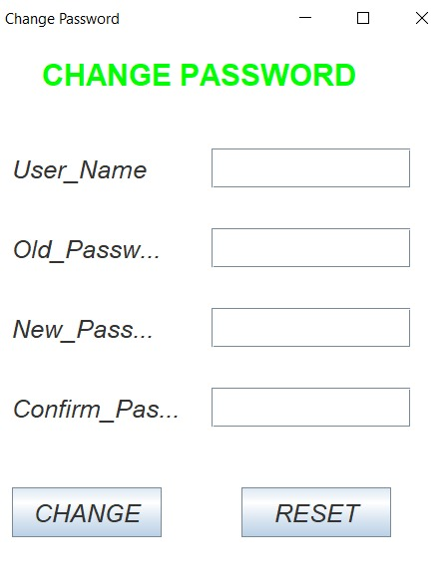

NEW CUSTOMER DETAILS

import java.awt.*;
import java.awt.event.*;
import java.sql.*;
import javax.swing.*;
import javax.swing.table.*;

class Frame1 extends Frame implements ActionListener, WindowListener
{
Label l1=new Label("Customer Details");
Label l2=new Label("Customer ID :-");
Label l3=new Label("Customer Name :-");
Label l4=new Label("Shop Name :-");
Label l5=new Label("Address :-");
Label l6=new Label("Ph.Number :-");

TextField t1=new TextField("");
TextField t2=new TextField("");
TextField t3=new TextField("");
TextArea ta=new TextArea("");
TextField t4=new TextField("");

Button b1=new Button("Add To Cart");
Button b2=new Button("Reset");
Button b3=new Button("submit");
Button b4=new Button("Delete");

Font f1=new Font ("Arial",Font.BOLD,30);
Font f2=new Font ("Arial",Font.PLAIN,18);

Connection con;
PreparedStatement st;
ResultSet rs;
int cid,pno;
String cname,sn,addr;
JTable jt;
DefaultTableModel model;
String
heads[]={"Customer ID","Customer Name","Shop Name","Address","Ph.Number"};

Frame1()
{
setSize(1100,700);
setLocationRelativeTo(null);
setLayout(null);
setResizable(false);
addWindowListener(this);
l1.setForeground(Color.GREEN);

l1.setBounds(150,50,250,30);add(l1);l1.setFont(f1);
l2.setBounds(50,120,150,30);add(l2);l2.setFont(f2);
l3.setBounds(50,180,150,30);add(l3);l3.setFont(f2);
l4.setBounds(50,240,150,30);add(l4);l4.setFont(f2);
l5.setBounds(50,300,150,30);add(l5);l5.setFont(f2);
l6.setBounds(50,380,150,30);add(l6);l6.setFont(f2);
t1.setBounds(230,120,200,30);add(t1);t1.setFont(f2);
t2.setBounds(230,180,200,30);add(t2);t2.setFont(f2);
t3.setBounds(230,240,200,30);add(t3);t3.setFont(f2);
ta.setBounds(230,300,200,60);add(ta);ta.setFont(f2);
t4.setBounds(230,380,200,30);add(t4);t4.setFont(f2);
b1.setBounds(110,520,100,30);add(b1);b1.setFont(f2);
b1.addActionListener(this);
b2.setBounds(240,520,100,30);add(b2);b2.setFont(f2);
b2.addActionListener(this);
b3.setBounds(570,620,100,30);add(b3);b3.setFont(f2);
b3.addActionListener(this);
b4.setBounds(700,620,100,30);add(b4);b4.setFont(f2);
b4.addActionListener(this);

try
{
Class.forName("com.mysql.jdbc.Driver");
con=DriverManager.getConnection("jdbc:mysql://localhost/bca","root","");

}
catch(Exception e)
{
System.out.print(e);
}

model=new DefaultTableModel();
model.setColumnIdentifiers(heads);
jt=new JTable();
jt.setModel(model);
model.setColumnIdentifiers(heads);
JScrollPane scroll=new JScrollPane(jt);
jt.setModel(model);
scroll.setBounds(500,40,550,550);add(scroll);

}

public void windowOpened(WindowEvent we)
{
}

public void windowActivated(WindowEvent we)
{
}

public void windowDeactivated(WindowEvent we)
{
}

public void windowIconified(WindowEvent we)
{
}

public void windowDeiconified(WindowEvent we)
{
}

public void windowClosed(WindowEvent we)
{
}

public void windowClosing(WindowEvent we)
{
dispose();
}

public void actionPerformed(ActionEvent ae)

{

if(ae.getSource()==b4)

{
model.removeRow(jt.getSelectedRow());
}
else if(ae.getSource()==b1)
{
cid=Integer.parseInt(t1.getText());
cname=t2.getText();
sn=t3.getText();
addr=ta.getText();
pno=Integer.parseInt(t4.getText());

model.addRow(new Object[]{cid,cname,sn,addr,pno});
t1.setText("er");
t1.setText("");
t2.setText("ds");
t2.setText("");
t3.setText("er");
t3.setText("");
t4.setText("gf");
t4.setText("");
ta.setText("er");
ta.setText("");

t1.requestFocus();

}

else if (ae.getSource()==b2)
{
t1.setText("er");
t1.setText("");
t2.setText("ds");
t2.setText("");
t3.setText("er");
t3.setText("");
t4.setText("gf");
t4.setText("");
ta.setText("er");
ta.setText("");

t1.requestFocus();

}

else if(ae.getSource()==b3)
{
for(int i=0;i<model.getRowCount();i++)
{
cid=Integer.parseInt(model.getValueAt(i,0).toString());
cname=model.getValueAt(i,1).toString();
sn=model.getValueAt(i,2).toString();
addr=model.getValueAt(i,3).toString();
pno=Integer.parseInt(model.getValueAt(i,4).toString());

try
{
st=con.prepareStatement("insert into custinfo values(?,?,?,?,?)");
st.setInt(1,cid);
st.setString(2,cname);
st.setString(3,sn);
st.setString(4,addr);
st. setInt(5,pno);
st.executeUpdate();

}

catch(Exception e)

{
System.out.print(e);
}

}
JOptionPane.showMessageDialog(null,"All Customer Add Successfully");
model.setRowCount(0);
t1.setText("er");
t1.setText("");
t2.setText("ds");
t2.setText("");
t3.setText("er");
t3.setText("");
t4.setText("gf");
t4.setText("");
ta.setText("er");
ta.setText("");

t1.requestFocus();

}

}

}

class customer
{
public static void main(String [] args)

{
Frame1 f=new Frame1();
f.setVisible(true);

}
}
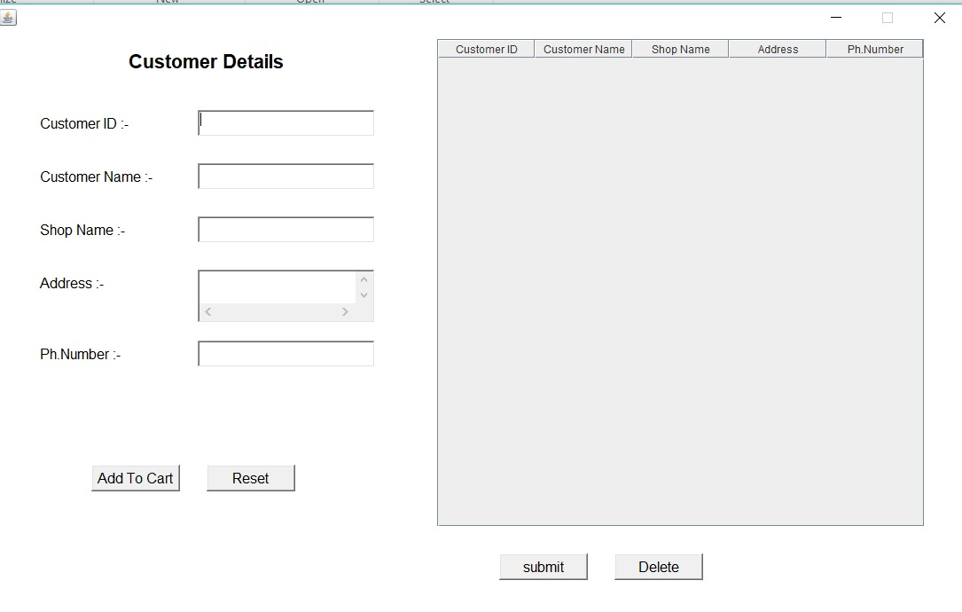
UPDATE CUSTOMER DETAILS

import java.awt.*;
import java.awt.event.*;
import javax.swing.*;
import java.sql.*;
class Frame1 extends Frame implements ActionListener,KeyListener
{
JLabel jl=new JLabel("Modify Customer Details");
JLabel l1=new JLabel("Customer I'd:-");
JLabel l2=new JLabel("Customer Name:-");
JLabel l3=new JLabel("Shop Name:-");
JLabel l4=new JLabel("Address:-");
JLabel l5=new JLabel("ph.Number:-");
JButton b1=new JButton("Search");
JTextField t1=new JTextField();
JTextField t2=new JTextField();
JTextField t3=new JTextField();
JTextArea ta=new JTextArea("Type your address",2,3);
JTextField t4=new JTextField();

JButton b2=new JButton("Submit");
JButton b3=new JButton("Delete");
JButton b4=new JButton("Reset");
Font fo=new Font("",1,33);
Font fn=new Font("",2,25);
Connection con;
PreparedStatement st;
ResultSet rs;
int id;
String ph,name,add,sn;
Frame1()
{
setLayout(null);
setSize(620,700);
setLocationRelativeTo(null);
setResizable(false);
Color c=new Color(225,179,255);
setBackground(c);
addWindowListener(new WindowAdapter()
{
public void windowClosing(WindowEvent e)
{
System.exit(0);
}
}
);
jl.setForeground(Color.GREEN);
jl.setBounds(100,50,410,50);add(jl);
jl.setFont(fo);add(jl);add(l1);
l1.setBounds(50,150,200,40);
l1.setFont(fn);add(l1);
l2.setBounds(50,230,200,40);add(l2);
l2.setFont(fn);add(l2);
l3.setBounds(50,310,200,40);add(l3);
l3.setFont(fn);add(l3);
l4.setBounds(50,390,200,40);add(l4);
l4.setFont(fn);add(l4);
l5.setBounds(50,470,200,40);add(l5);
l5.setFont(fn);add(l5);
t1.setBounds(320,150,235,40);add(t1);
t1.setFont(fn);add(t1);
t2.setBounds(320,230,235,40);add(t2);
t1.addKeyListener(this);
t2.setFont(fn);add(t2);
t3.setBounds(320,310,235,40);add(t3);
t3.setFont(fn);add(t3);
ta.setBounds(320,390,235,60);add(ta);
ta.setFont(fn);add(ta);
t4.setBounds(320,470,235,40);add(t4);
t4.setFont(fn);add(t4);
b1.setBounds(50,570,115,40);add(b1);
b1.setFont(fn);add(b1);
b1.addActionListener(this);
b2.setBounds(180,570,115,40);add(b2);
b2.setFont(fn);add(b2);
b2.addActionListener(this);
b3.setBounds(310,570,110,40);add(b3);
b3.setFont(fn);add(b3);
b3.addActionListener(this);
b4.setBounds(440,570,110,40);add(b4);
b4.setFont(fn);add(b4);
b4.addActionListener(this);

try
{
Class.forName("com.mysql.jdbc.Driver");
con=DriverManager.getConnection("jdbc:mysql://localhost/bca","root","");
}
catch(Exception ex)
{
System.out.println(ex);
}
}
public void keyPressed(KeyEvent ke)
{
char c=ke.getKeyChar();
if((c>='0' && c<='9') || (c==' ') || (c=='\b'))
{
t1.setEditable(true);
}
else
{
t1.setEditable(false);
}
}
public void keyReleased(KeyEvent ke)
{
}
public void keyTyped(KeyEvent ke)
{
}
public void actionPerformed(ActionEvent e)
{
if(e.getSource()==b3)
{
id=Integer.parseInt(t1.getText());
try
{
st=con.prepareStatement("delete from reg where Customer_id=? ");
st.setInt(1,id);
st.executeUpdate();
JOptionPane.showMessageDialog(null,"Customer Details Delete Successfully !");
t1.setText("se");
t1.setText("");
t2.setText("cd");
t2.setText("");
t3.setText("sd");
t3.setText("");
ta.setText("st");
ta.setText("");
t4.setText("hh");
t4.setText("");
t1.requestFocus();
}
catch(Exception ed)
{
System.out.println(ed);
}
}
else if(e.getSource()==b4)
{
t1.setText("se");
t1.setText("");
t2.setText("cd");
t2.setText("");
t3.setText("sd");
t3.setText("");
ta.setText("st");
ta.setText("");
t4.setText("hh");
t4.setText("");
t1.requestFocus();
}
else if(e.getSource()==b1)
{
id=Integer.parseInt(t1.getText());
try
{
st=con.prepareStatement("select * from reg where Customer_id=?");
st.setInt(1,id);
rs=st.executeQuery();
if(rs.next())
{
name=rs.getString("Customer_name");
sn=rs.getString("Shop_name");
add=rs.getString("Address");
ph=rs.getString("Phone_no");
t2.setText(name);
t3.setText(sn);
ta.setText(add);
t4.setText(ph);
}
else
{
JOptionPane.showMessageDialog(null,"Ivalid Customer I'd !");
}
}
catch(Exception et)
{
System.out.println(et);
}
}

else if(e.getSource()==b2)
{
id=Integer.parseInt(t1.getText());
name=t2.getText();
sn=t3.getText();
add=ta.getText();
ph=t4.getText();
//int x=String.valueOf(id).length();
if(name.length()==0 || ph.length()==0 || add.length()==0 || sn.length()==0 || String.valueOf(id).length()==0)
{
JOptionPane.showMessageDialog(null,"Please Fill All Entries");
t1.requestFocus();
}
else
{
try
{
st=con.prepareStatement("update reg set Customer_name=?,Shop_name=?,Address=?,Phone_no=? where Customer_id=?");
st.setString(1,name);
st.setString(2,sn);
st.setString(3,add);
st.setString(4,ph);
st.setInt(5,id);
st.executeUpdate();
JOptionPane.showMessageDialog(null,"Modify Successfully");
t1.setText("sd");
t1.setText("");
t2.setText("es");
t2.setText("");
t3.setText("tf");
t3.setText("");
ta.setText("ed");
ta.setText("");
t4.setText("dc");
t4.setText("");
t1.requestFocus();
}
catch(Exception ec)
{
System.out.println(ec);
}
}
}
}
}
class mcd
{
public static void main(String args[])
{
Frame1 f=new Frame1();
f.setVisible(true);
}
}

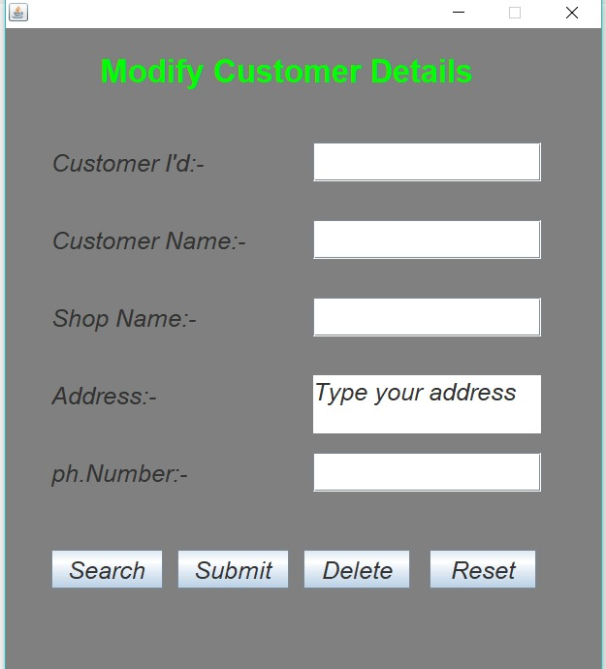

NEW EMPLOYEE DETAILS

import java.awt.*;
import java.awt.event.*;
import java.sql.*;
import javax.swing.*;
import javax.swing.table.*;
class Frame1 extends Frame implements ActionListener
{
JLabel jl=new JLabel("Employee Details");
JLabel l1=new JLabel("Emoloyee ID");
JLabel l2=new JLabel("Employee Name");
JLabel l3=new JLabel("Designation");
JLabel l4=new JLabel("Salary");
JLabel l5=new JLabel("Phone No.");
JLabel l6=new JLabel("Address");
JLabel l7=new JLabel("E.Mail");
JLabel l8=new JLabel("Date_of_Joing");
JTextField t1=new JTextField();
JTextField t2=new JTextField();
JTextField t3=new JTextField();
JTextField t4=new JTextField();
JTextField t5=new JTextField();
JTextField t6=new JTextField();
JTextField t7=new JTextField();
JTextField t8=new JTextField();
JButton b1=new JButton("Add TO Cart");
JButton b2=new JButton("Reset");
JButton b3=new JButton("Submit");
JButton b4=new JButton("Delete");

Font fo=new Font("",1,30);
Font fn=new Font("",2,23);
Font ft=new Font("",1,20);
DefaultTableModel model=new DefaultTableModel();
JTable t=new JTable();
String head[]={"EmpI'd","EmpName","Designation","Salary","PhoneNo","Address","E.Mail","D.O.J."};
Connection con;
PreparedStatement st;
ResultSet rs;
String eid,enm,add,eml,deg,doj,ph;
int sal;
Frame1()
{
setLayout(null);
setSize(1250,900);
setLocationRelativeTo(null);
setResizable(false);
addWindowListener(new WindowAdapter()
{
public void windowClosing(WindowEvent e)
{
System.exit(0);
}
}
);
jl.setForeground(Color.GREEN);
jl.setBounds(110,50,300,50);add(jl);
jl.setFont(fo);add(jl);
l1.setBounds(50,150,150,40);add(l1);
l1.setFont(fn);add(l1);
l2.setBounds(50,230,150,40);add(l2);
l2.setFont(fn);add(l2);
l3.setBounds(50,310,150,40);add(l3);
l3.setFont(fn);add(l3);
l4.setBounds(50,390,150,40);add(l4);
l4.setFont(fn);add(l4);
l5.setBounds(50,470,150,40);add(l5);
l5.setFont(fn);add(l5);
l6.setBounds(50,550,150,40);add(l6);
l6.setFont(fn);add(l6);
l7.setBounds(50,630,150,40);add(l7);
l7.setFont(fn);add(l7);
l8.setBounds(50,710,150,40);add(l8);
l8.setFont(fn);add(l8);
t1.setBounds(250,150,180,40);add(t1);
t1.setFont(fn);add(t1);
t2.setBounds(250,230,180,40);add(t2);
t2.setFont(fn);add(t2);
t3.setBounds(250,310,180,40);add(t3);
t3.setFont(fn);add(t3);
t4.setBounds(250,390,180,40);add(t4);
t4.setFont(fn);add(t4);
t5.setBounds(250,470,180,40);add(t5);
t5.setFont(fn);add(t5);
t6.setBounds(250,550,180,40);add(t6);
t6.setFont(fn);add(t6);
t7.setBounds(250,630,180,40);add(t7);
t7.setFont(fn);add(t7);
t8.setBounds(250,710,180,40);add(t8);
t8.setFont(fn);add(t8);
b1.setBounds(50,800,170,40);add(b1);
b1.setFont(fn);add(b1);
b2.setBounds(260,800,170,40);add(b2);
b2.setFont(fn);add(b2);
model.setColumnIdentifiers(head);
t.setModel(model);
JTableHeader th=t.getTableHeader();
th.setFont(ft);
JScrollPane scr=new JScrollPane(t);
scr.setBounds(480,50,760,620);add(scr);
b3.setBounds(580,800,160,40);add(b3);
b3.setFont(fn);add(b3);
b4.setBounds(900,800,160,40);add(b4);
b4.setFont(fn);add(b4);
try
{
Class.forName("com.mysql.jdbc.Driver");
con=DriverManager.getConnection("jdbc:mysql://localhost/bca","root","");
}
catch(Exception ec)
{
System.out.println(ec);
}
b1.addActionListener(this);
b2.addActionListener(this);
b3.addActionListener(this);
b4.addActionListener(this);
}
public void actionPerformed(ActionEvent e)
{
if(e.getSource()==b1)
{
eid=t1.getText();
enm=t2.getText();
deg=t3.getText();
sal=Integer.parseInt(t4.getText());
ph=t5.getText();
add=t6.getText();
eml=t7.getText();
doj=t8.getText();
model.addRow(new Object[]{eid,enm,deg,sal,ph,add,eml,doj});
t1.setText("f");
t1.setText("");
t2.setText("e");
t2.setText("");
t3.setText("m");
t3.setText("");
t4.setText("j");
t4.setText("");
t5.setText("w");
t5.setText("");
t6.setText("s");
t6.setText("");
t7.setText("n");
t7.setText("");
t8.setText("k");
t8.setText("");
t1.requestFocus();
}
else if(e.getSource()==b2)
{
t1.setText("f");
t1.setText("");
t2.setText("e");
t2.setText("");
t3.setText("m");
t3.setText("");
t4.setText("j");
t4.setText("");
t5.setText("w");
t5.setText("");
t6.setText("s");
t6.setText("");
t7.setText("n");
t7.setText("");
t8.setText("k");
t8.setText("");
}
else if(e.getSource()==b3)
{
for(int i=0;i<model.getRowCount();i++)
{
eid=model.getValueAt(i,0).toString();
enm=model.getValueAt(i,1).toString();
deg=model.getValueAt(i,2).toString();
sal=Integer.parseInt(model.getValueAt(i,3).toString());
ph=model.getValueAt(i,4).toString();
add=model.getValueAt(i,5).toString();
eml=model.getValueAt(i,6).toString();
doj=model.getValueAt(i,7).toString();
try
{
st=con.prepareStatement("insert into Empinfo values(?,?,?,?,?,?,?,?)");
st.setString(1,eid);
st.setString(2,enm);
st.setString(3,deg);
st.setInt(4,sal);
st.setString(5,ph);
st.setString(6,add);
st.setString(7,eml);
st.setString(8,doj);
st.executeUpdate();
}
catch(Exception es)
{
System.out.println(es);
}
}
JOptionPane.showMessageDialog(null,"Employee Details Fill Successfully!");
model.setRowCount(0);
}
else if(e.getSource()==b4)
{
model.removeRow(t.getSelectedRow());
}
}
}
class Emp
{
public static void main(String args[])
{
Frame1 f=new Frame1();
f.setVisible(true);
}
}

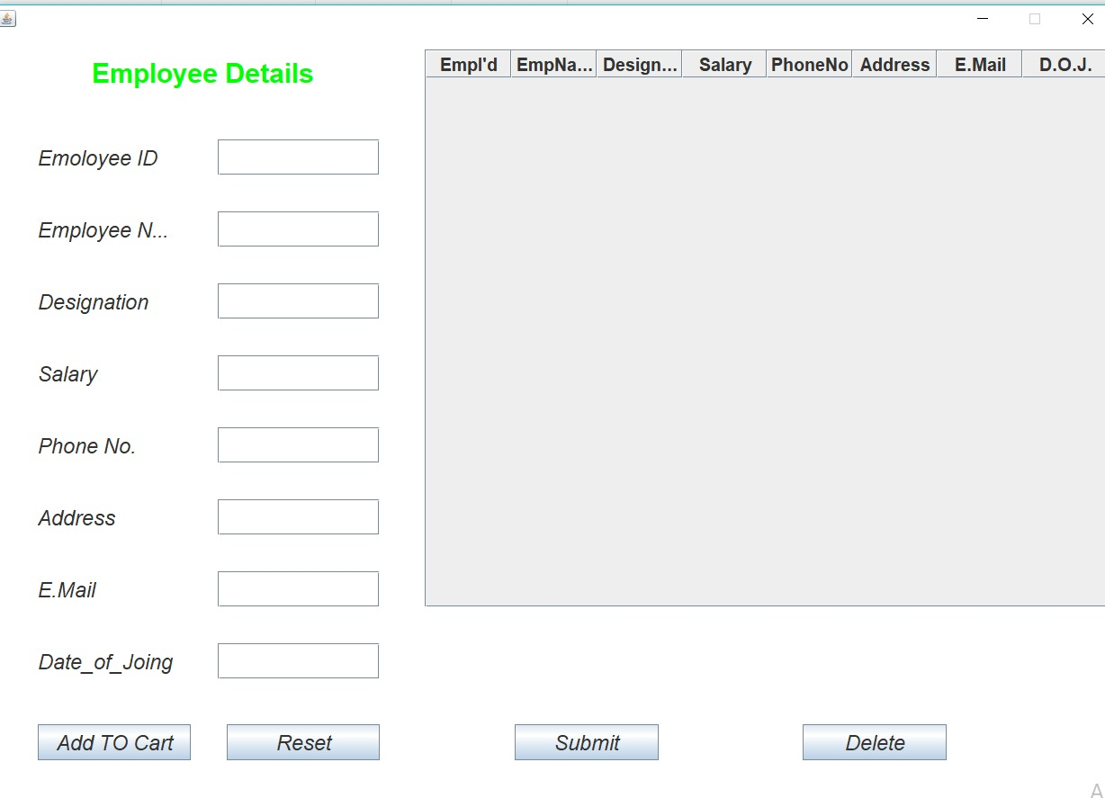

UPDATE EMPLOYEE DETAILS

import java.awt.*;
import java.awt.event.*;
import javax.swing.*;
import java.sql.*;
class Frame1 extends Frame implements ActionListener//,KeyListener
{
JLabel jl=new JLabel("Modify Employee Details !");

JLabel l1=new JLabel("Emoloyee ID");
JLabel l2=new JLabel("Employee Name");
JLabel l3=new JLabel("Designation");
JLabel l4=new JLabel("Salary");
JLabel l5=new JLabel("Phone No.");
JLabel l6=new JLabel("Address");
JLabel l7=new JLabel("E.Mail");
JLabel l8=new JLabel("Date_of_Joing");
JTextField t1=new JTextField();
JTextField t2=new JTextField();
JTextField t3=new JTextField();
JTextField t4=new JTextField();
JTextField t5=new JTextField();
JTextField t6=new JTextField();
JTextField t7=new JTextField();
JTextField t8=new JTextField();
JButton b1=new JButton("Search");
JButton b2=new JButton("Submit");
JButton b3=new JButton("Delete");
JButton b4=new JButton("Reset");
Font fo=new Font("",1,30);
Font fn=new Font("",2,23);
Connection con;
PreparedStatement st;
ResultSet rs;
String eid,enm,deg,ph,add,eml,doj;
int sal;
Frame1()
{
setLayout(null);
setSize(650,900);
setLocationRelativeTo(null);
setResizable(false);
addWindowListener(new WindowAdapter()
{
public void windowClosing(WindowEvent e)
{
System.exit(0);
}
}
);
jl.setForeground(Color.GREEN);
jl.setBounds(110,50,380,50);add(jl);
jl.setFont(fo);add(jl);
l1.setBounds(50,150,150,40);add(l1);
l1.setFont(fn);add(l1);
l2.setBounds(50,230,190,40);add(l2);
l2.setFont(fn);add(l2);
l3.setBounds(50,310,150,40);add(l3);
l3.setFont(fn);add(l3);
l4.setBounds(50,390,150,40);add(l4);
l4.setFont(fn);add(l4);
l5.setBounds(50,470,150,40);add(l5);
l5.setFont(fn);add(l5);
l6.setBounds(50,550,150,40);add(l6);
l6.setFont(fn);add(l6);
l7.setBounds(50,630,150,40);add(l7);
l7.setFont(fn);add(l7);
l8.setBounds(50,710,150,40);add(l8);
l8.setFont(fn);add(l8);
t1.setBounds(290,150,260,40);add(t1);
t1.setFont(fn);add(t1);
t2.setBounds(290,230,260,40);add(t2);
t2.setFont(fn);add(t2);
t3.setBounds(290,310,260,40);add(t3);
t3.setFont(fn);add(t3);
t4.setBounds(290,390,260,40);add(t4);
t4.setFont(fn);add(t4);
t5.setBounds(290,470,260,40);add(t5);
t5.setFont(fn);add(t5);
t6.setBounds(290,550,260,40);add(t6);
t6.setFont(fn);add(t6);
t7.setBounds(290,630,260,40);add(t7);
t7.setFont(fn);add(t7);
t8.setBounds(290,710,260,40);add(t8);
t8.setFont(fn);add(t8);
b1.setBounds(40,800,120,40);add(b1);
b1.setFont(fn);add(b1);
b2.setBounds(170,800,120,40);add(b2);
b2.setFont(fn);add(b2);
b3.setBounds(300,800,120,40);add(b3);
b3.setFont(fn);add(b3);
b4.setBounds(435,800,130,40);add(b4);
b4.setFont(fn);add(b4);
try
{
Class.forName("com.mysql.jdbc.Driver");
con=DriverManager.getConnection("jdbc:mysql://localhost/bca","root","");
}
catch(Exception ex)
{
System.out.println(ex);
}
b1.addActionListener(this);
b2.addActionListener(this);
b3.addActionListener(this);
b4.addActionListener(this);
}

/*public void keyPressed(KeyEvent ke)
{
char c=ke.getKeyChar();
if((c>='0' && c<='9') || (c==' ') || (c=='\b'))
{
t1.setEditable(true);
}
else
{
t1.setEditable(false);
}
}
public void keyReleased(KeyEvent ke)
{
}
public void keyTyped(KeyEvent ke)
{
}*/

public void actionPerformed(ActionEvent e)
{
if(e.getSource()==b3)
{
eid=t1.getText();
try
{
st=con.prepareStatement("delete from Empinfo where EmpId=?");
st.setString(1,eid);
st.executeUpdate();
JOptionPane.showMessageDialog(null,"Employee Info Delete Successfully!");
t1.setText("ew");
t1.setText("");
t2.setText("gf");
t2.setText("");
t3.setText("ed");
t3.setText("");
t4.setText("ws");
t4.setText("");
t5.setText("qa");
t5.setText("");
t6.setText("az");
t6.setText("");
t7.setText("sx");
t7.setText("");
t8.setText("fv");
t8.setText("");
t1.requestFocus();
}
catch(Exception ed)
{
System.out.print("Delete Error"+ed);
}
}
else if(e.getSource()==b2)
{
try
{
eid=t1.getText();
enm=t2.getText();
deg=t3.getText();
sal=Integer.parseInt(t4.getText());
ph=t5.getText();
add=t6.getText();
eml=t7.getText();
doj=t8.getText();
st=con.prepareStatement("update Empinfo set EmpName=?,Designation=?,Salary=?,PhoneNo=?,Address=?,EMail=?,DateOfJoning=? where EmpId=?");
st.setString(1,enm);
st.setString(2,deg);
st.setInt(3,sal);
st.setString(4,ph);
st.setString(5,add);
st.setString(6,eml);
st.setString(7,doj);
st.setString(8,eid);
st.executeUpdate();
JOptionPane.showMessageDialog(null,"Employee Details Modify Successfully!");
t1.setText("ew");
t1.setText("");
t2.setText("gf");
t2.setText("");
t3.setText("ed");
t3.setText("");
t4.setText("ws");
t4.setText("");
t5.setText("qa");
t5.setText("");
t6.setText("az");
t6.setText("");
t7.setText("sx");
t7.setText("");
t8.setText("fv");
t8.setText("");
t1.requestFocus();
}
catch(Exception eu)
{
System.out.println("Update Error"+eu);
}
}
if(e.getSource()==b4)
{
t1.setText("ew");
t1.setText("");
t2.setText("gf");
t2.setText("");
t3.setText("ed");
t3.setText("");
t4.setText("ws");
t4.setText("");
t5.setText("qa");
t5.setText("");
t6.setText("az");
t6.setText("");
t7.setText("sx");
t7.setText("");
t8.setText("fv");
t8.setText("");
}
else if(e.getSource()==b1)
{
eid=t1.getText();
try
{
st=con.prepareStatement("select * from Empinfo where EmpId=?");
st.setString(1,eid);
rs=st.executeQuery();
if(rs.next())
{
enm=rs.getString("EmpName");
deg=rs.getString("Designation");
sal=rs.getInt("Salary");
ph=rs.getString("PhoneNo");
add=rs.getString("Address");
eml=rs.getString("Email");
doj=rs.getString("DateOfJoning");
t2.setText(enm);
t3.setText(deg);
t4.setText(String.valueOf(sal));
t5.setText(ph);
t6.setText(add);
t7.setText(eml);
t8.setText(doj);
}
else
{
JOptionPane.showMessageDialog(null,"Ivalid Employee I'd !");
}
}
catch(Exception et)
{
System.out.println("Error"+et);
}
}
}

}
class Emod
{
public static void main(String args[])
{
Frame1 f=new Frame1();
f.setVisible(true);
}
}

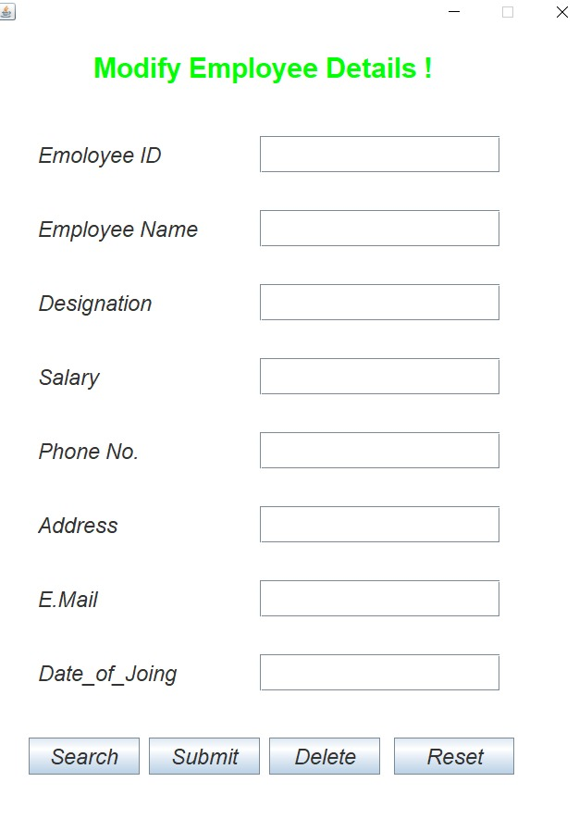

ATTENDANCE

import java.awt.*;
import java.util.Date;
import java.awt.event.*;
import javax.swing.*;
import javax.swing.table.*;
import java.sql.*;
class Frame1 extends Frame implements ActionListener
{
JLabel jl=new JLabel("Mark Daily Attendence");
JLabel l1=new JLabel("Date");
JTextField t1=new JTextField();
Date dd=new Date();
JButton b=new JButton("Mark");
JLabel jl1=new JLabel("Employee Table");
JButton b1=new JButton("Submit");
JButton b2=new JButton("Reset");
DefaultTableModel model=new DefaultTableModel();
JTable t=new JTable();
String head[]={"S.no","Employee_I'd","Employee_Name","Status"};
Connection con;
PreparedStatement st;
ResultSet rs;
String dt,ed,en,da,sta;
int sn;
Font fo=new Font("",1,30);
Font fn=new Font("",2,25);
Frame1()
{
setLayout(null);
setSize(650,900);
setLocationRelativeTo(null);
setResizable(false);
setTitle("STOCKZ");
addWindowListener(new WindowAdapter()
{
public void windowClosing(WindowEvent e)
{
System.exit(0);
}
}
);
jl.setForeground(Color.GREEN);
jl.setBounds(170,100,400,50);add(jl);
jl.setFont(fo);add(jl);
l1.setBounds(120,200,120,40);add(l1);
l1.setFont(fn);add(l1);
t1.setBounds(300,200,200,40);add(t1);
t1.setFont(fn);add(t1);
dt=String.valueOf(dd);
dt=dt.substring(8,10)+"/"+dt.substring(4,7)+"/"+dt.substring(24);
t1.setText(dt);
t1.setEditable(false);
b.setBounds(240,280,120,40);add(b);
b.setFont(fn);add(b);
jl1.setForeground(Color.BLUE);
jl1.setBounds(200,350,400,50);add(jl1);
jl1.setFont(fo);add(jl1);
model.setColumnIdentifiers(head);
t.setModel(model);

JScrollPane scr=new JScrollPane(t);
scr.setBounds(50,400,550,300);
add(scr);
b1.setBounds(130,780,120,40);add(b1);
b1.setFont(fn);add(b1);
b2.setBounds(400,780,120,40);add(b2);
b2.setFont(fn);add(b2);

try
{
Class.forName("com.mysql.jdbc.Driver");
con=DriverManager.getConnection("jdbc:mysql://localhost/bca","root","");
}
catch(Exception ec)
{
System.out.println(ec);
}

b2.addActionListener(this);
b1.addActionListener(this);
b.addActionListener(this);
}
public void actionPerformed(ActionEvent e)
{
if(e.getSource()==b2)
{
model.setRowCount(0);
}
else if(e.getSource()==b)
{
try
{
st=con.prepareStatement("Select * from emp");
rs=st.executeQuery();
while(rs.next())
{
sn=rs.getInt(1);
ed=rs.getString(2);
en=rs.getString(3);
model.addRow(new Object[]{sn,ed,en});

}
}
catch(Exception et)
{
System.out.print(et);
}
}

else if(e.getSource()==b1)
{
for(int i=0;i<model.getRowCount();i++)
{
sn=Integer.parseInt(model.getValueAt(i,0).toString());
ed=model.getValueAt(i,1).toString();
en=model.getValueAt(i,2).toString();
sta=model.getValueAt(i,3).toString();
da=t1.getText();
JOptionPane.showMessageDialog(null,ed+"\n"+en+"\n"+sta+"\n"+da);
try{
st=con.prepareStatement("insert into Attendencedata values(?,?,?,?)");
st.setString(1,da);
st.setString(2,ed);
st.setString(3,en);
st.setString(4,sta);
st.executeUpdate();

}
catch(Exception es)
{
//System.out.println(es);
}
}
JOptionPane.showMessageDialog(null,"Attendence Fill Successfully!");
model.setRowCount(0);
}

}
}

class Att
{
public static void main(String args[])
{
Frame1 f=new Frame1();
f.setVisible(true);
}
}
}
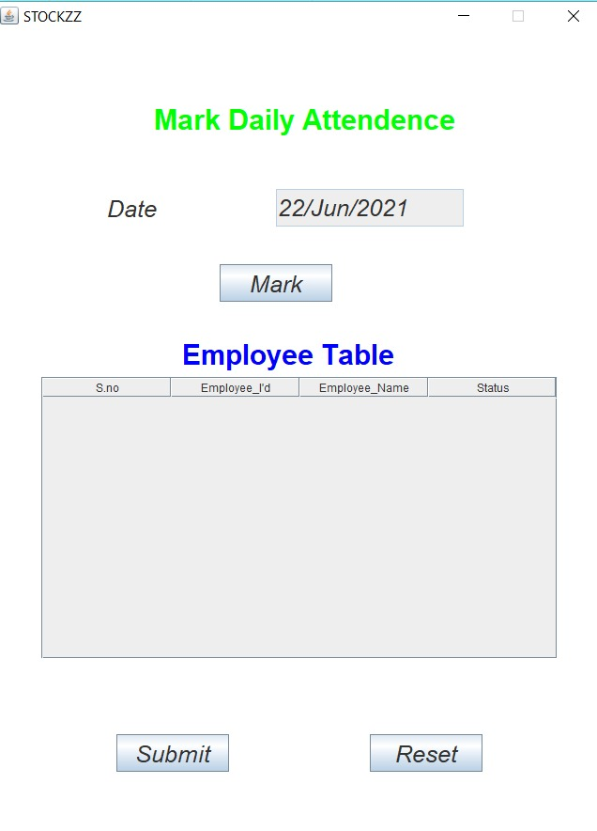

UPDATE ATTENDANCE

import java.awt.*;
import java.awt.event.*;
import javax.swing.*;
import java.sql.*;
import javax.swing.table.*;

class modatt extends Frame implements ActionListener
{
JLabel jl=new JLabel("Modify Attendence");
JLabel jl1=new JLabel("Employee Table");
JLabel l1=new JLabel("Date");
JTextField t1=new JTextField();
JButton b1=new JButton("Mark");
JButton b2=new JButton("Submit");
JButton b3=new JButton("Reset");

Font fo=new Font("",1,30);
Font fn=new Font("",2,25);
DefaultTableModel model=new DefaultTableModel();
JTable t=new JTable();
String heads[]={"S.no","Employee Id","Employee Name","Status"};
Connection con;
PreparedStatement st;
ResultSet rs;
String dt,ed,en,da,sta;
int sn;
modatt()
{
setLayout(null);
setSize(650,900);
setLocationRelativeTo(null);
setResizable(false);
setTitle("STOCKZ");
jl.setForeground(Color.GREEN);
jl.setBounds(170,100,400,50);add(jl);
jl.setFont(fo);add(jl);
l1.setBounds(120,200,120,40);add(l1);
l1.setFont(fn);add(l1);
t1.setBounds(300,200,200,40);add(t1);
t1.setFont(fn);add(t1);
b1.setBounds(240,280,120,40);add(b1);
b1.setFont(fn);add(b1);
b2.setBounds(130,780,120,40);add(b2);
b2.setFont(fn);add(b2);
b3.setBounds(400,780,120,40);add(b3);
b3.setFont(fn);add(b3);
jl1.setForeground(Color.BLUE);
jl1.setBounds(200,350,400,50);add(jl1);
jl1.setFont(fo);add(jl1);
model.setColumnIdentifiers(heads);
t.setModel(model);
JScrollPane scr=new JScrollPane(t);
scr.setBounds(50,400,550,300);
add(scr);
try
{
Class.forName("com.mysql.jdbc.Driver");
con=DriverManager.getConnection("jdbc:mysql://localhost/bca","root","");
}
catch(Exception ec)
{
System.out.println(ec);
}
b1.addActionListener(this);
b2.addActionListener(this);
b3.addActionListener(this);
}
public void actionPerformed(ActionEvent e)
{
if(e.getSource()==b3)
{
model.setRowCount(0);
}
else if(e.getSource()==b1)
{
dt=t1.getText();
try
{
st=con.prepareStatement("Select * from attendencedata where date=?");
st.setString(1,dt);
rs=st.executeQuery();
sn=1;
while(rs.next())
{
ed=rs.getString(2);
en=rs.getString(3);
sta=rs.getString(4);
model.addRow(new Object[]{sn,ed,en,sta});
sn++;
}
}
catch(Exception et)
{
System.out.print(et);
}
}
else if(e.getSource()==b2)
{
for(int i=0;i<model.getRowCount();i++)
{
sn=Integer.parseInt(model.getValueAt(i,0).toString());
ed=model.getValueAt(i,1).toString();
en=model.getValueAt(i,2).toString();
sta=model.getValueAt(i,3).toString();
try
{
st=con.prepareStatement("update attendencedata set empid=?,empname=?,status=? where date=?");
st.setString(1,ed);
st.setString(2,en);
st.setString(3,sta);
st.setString(4,dt);
st.executeUpdate();
}
catch(Exception el)
{
System.out.print(el);
}
}
JOptionPane.showMessageDialog(null,"Attendence Update Successfully!");
}
else if(e.getSource()==b3)
{

}

}
}
class modifyAtt
{
public static void main(String args[])
{
modatt a=new modatt();
a.setVisible(true);
}
}
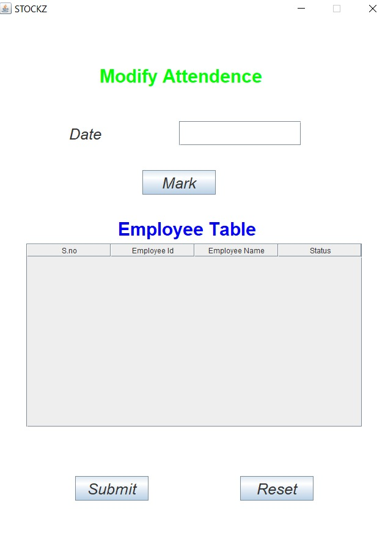


NEW ITEM

import java.awt.*;
import java.awt.event.*;
import javax.swing.*;
import java.sql.*;
class Frame1 extends Frame implements ActionListener
{
JLabel jl=new JLabel("Add New Item! ");
JLabel l1=new JLabel("Item Code");
JLabel l2=new JLabel("Item Name");
JLabel l3=new JLabel("Description");
JTextField t1=new JTextField();
JTextField t2=new JTextField();
JTextField t3=new JTextField();
JButton b1=new JButton("Submit");
JButton b2=new JButton("Reset");
Font fo=new Font("",1,30);
Font fn=new Font("",2,25);
Connection con;
PreparedStatement st;
ResultSet rs;
String icode,iname,idesc;
Frame1()
{
setLayout(null);
setSize(510,530);
setLocationRelativeTo(null);
setResizable(false);
addWindowListener(new WindowAdapter ()
{
public void windowClosing(WindowEvent e)
{
System.exit(0);
}
});
jl.setForeground(Color.green);
jl.setBounds(150,50,300,50);add(jl);
jl.setFont(fo);add(jl);
l1.setBounds(60,150,150,40);add(l1);
l1.setFont(fn);add(l1);
l2.setBounds(60,240,150,40);add(l2);
l2.setFont(fn);add(l2);
l3.setBounds(60,330,150,40);add(l3);
l3.setFont(fn);add(l3);
t1.setBounds(250,150,200,40);add(t1);
t1.setFont(fn);add(t1);
t2.setBounds(250,240,200,40);add(t2);
t2.setFont(fn);add(t2);
t3.setBounds(250,330,200,40);add(t3);
t3.setFont(fn);add(t3);
b1.setBounds(60,420,140,40);add(b1);
b1.setFont(fn);add(b1);
b2.setBounds(310,420,140,40);add(b2);
b2.setFont(fn);add(b2);
try
{
Class.forName("com.mysql.jdbc.Driver");
con=DriverManager.getConnection("jdbc:mysql://localhost/bca","root","");
}
catch(Exception ec)
{
System.out.println(ec);
}
b1.addActionListener(this);
b2.addActionListener(this);
}
public void actionPerformed(ActionEvent e)
{
if(e.getSource()==b1)
{
icode=t1.getText();
iname=t2.getText();
idesc=t3.getText();
try
{
st=con.prepareStatement("Select * from iteminfo where itemcode=?");
st.setString(1,icode);
rs=st.executeQuery();
if(rs.next())
{
JOptionPane.showMessageDialog(null,"Already exists");
t1.requestFocus();
}
else
{
st=con.prepareStatement("insert into iteminfo values(?,?,?,'0','0','0','0','0','0')");
st.setString(1,icode);
st.setString(2,iname);
st.setString(3,idesc);
st.executeUpdate();
JOptionPane.showMessageDialog(null,"New Item Added Successfully!");
t1.setText("qw");
t1.setText("");
t2.setText("ew");
t2.setText("");
t3.setText("sd");
t3.setText("");
t1.requestFocus();
}
}
catch(Exception es)
{
System.out.println(es);
}

}
else if(e.getSource()==b2)
{
t1.setText("qw");
t1.setText("");
t2.setText("ew");
t2.setText("");
t3.setText("sd");
t3.setText("");
}

}
}
class NewItem
{
public static void main(String args[])
{
Frame1 f=new Frame1();
f.setVisible(true);
}
}
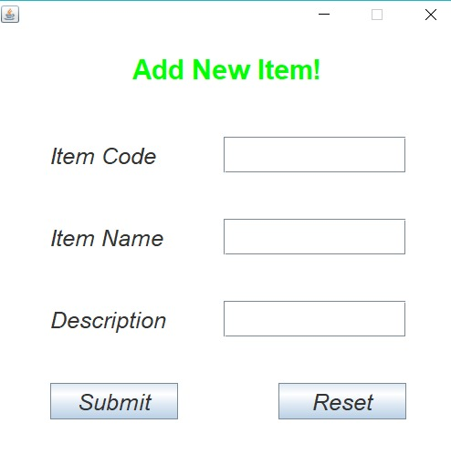
UPDATE ITEM

import java.awt.*;
import java.awt.event.*;
import javax.swing.*;
import java.sql.*;
class Frame1 extends Frame implements ActionListener
{
JLabel jl=new JLabel("Add New Item! ");
JLabel l1=new JLabel("Item Code");
JLabel l2=new JLabel("Item Name");
JLabel l3=new JLabel("Description");
JTextField t1=new JTextField();
JTextField t2=new JTextField();
JTextField t3=new JTextField();
JButton b1=new JButton("Submit");
JButton b2=new JButton("Reset");
Font fo=new Font("",1,30);
Font fn=new Font("",2,25);
Connection con;
PreparedStatement st;
ResultSet rs;
String icode,iname,idesc;
Frame1()
{
setLayout(null);
setSize(510,530);
setLocationRelativeTo(null);
setResizable(false);
addWindowListener(new WindowAdapter ()
{
public void windowClosing(WindowEvent e)
{
System.exit(0);
}
});
jl.setForeground(Color.green);
jl.setBounds(150,50,300,50);add(jl);
jl.setFont(fo);add(jl);
l1.setBounds(60,150,150,40);add(l1);
l1.setFont(fn);add(l1);
l2.setBounds(60,240,150,40);add(l2);
l2.setFont(fn);add(l2);
l3.setBounds(60,330,150,40);add(l3);
l3.setFont(fn);add(l3);
t1.setBounds(250,150,200,40);add(t1);
t1.setFont(fn);add(t1);
t2.setBounds(250,240,200,40);add(t2);
t2.setFont(fn);add(t2);
t3.setBounds(250,330,200,40);add(t3);
t3.setFont(fn);add(t3);
b1.setBounds(60,420,140,40);add(b1);
b1.setFont(fn);add(b1);
b2.setBounds(310,420,140,40);add(b2);
b2.setFont(fn);add(b2);
try
{
Class.forName("com.mysql.jdbc.Driver");
con=DriverManager.getConnection("jdbc:mysql://localhost/bca","root","");
}
catch(Exception ec)
{
System.out.println(ec);
}
b1.addActionListener(this);
b2.addActionListener(this);
}
public void actionPerformed(ActionEvent e)
{
if(e.getSource()==b1)
{
icode=t1.getText();
iname=t2.getText();
idesc=t3.getText();
try
{
st=con.prepareStatement("Select * from iteminfo where itemcode=?");
st.setString(1,icode);
rs=st.executeQuery();
if(rs.next())
{
JOptionPane.showMessageDialog(null,"Already exists");
t1.requestFocus();
}
else
{
st=con.prepareStatement("insert into iteminfo values(?,?,?,'0','0','0','0','0','0')");
st.setString(1,icode);
st.setString(2,iname);
st.setString(3,idesc);
st.executeUpdate();
JOptionPane.showMessageDialog(null,"New Item Added Successfully!");
t1.setText("qw");
t1.setText("");
t2.setText("ew");
t2.setText("");
t3.setText("sd");
t3.setText("");
t1.requestFocus();
}
}
catch(Exception es)
{
System.out.println(es);
}

}
else if(e.getSource()==b2)
{
t1.setText("qw");
t1.setText("");
t2.setText("ew");
t2.setText("");
t3.setText("sd");
t3.setText("");
}

}
}
class NewItem
{
public static void main(String args[])
{
Frame1 f=new Frame1();
f.setVisible(true);
}
}
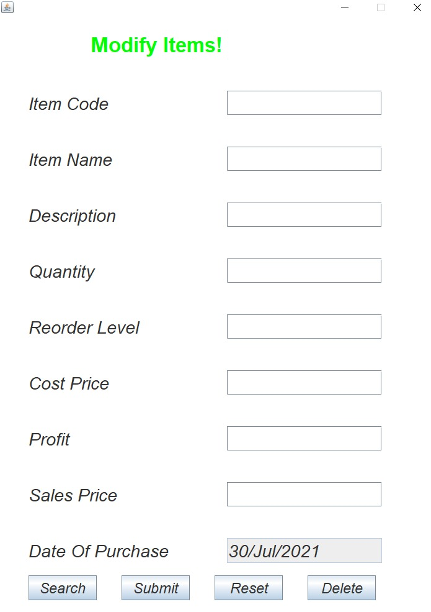
PURCHASE ITEM

import java.awt.*;
import java.util.Date;
import javax.swing.*;
import java.awt.event.*;
import java.sql.*;
class Frame1 extends Frame implements ActionListener
{
JLabel jl=new JLabel("Purchase Items Details! ");
JLabel l1=new JLabel("Item Code");
JLabel l2=new JLabel("Item Name");
JLabel l3=new JLabel("Description");
JLabel l4=new JLabel("Quantity");
JLabel l5=new JLabel("Reorder Level");
JLabel l6=new JLabel("Cost Price");
JLabel l7=new JLabel("Profit");
JLabel l8=new JLabel("Sales Price");
JLabel l9=new JLabel("Date Of Purchase");
JTextField t1=new JTextField();
JTextField t2=new JTextField();
JTextField t3=new JTextField();
JTextField t4=new JTextField();
JTextField t5=new JTextField();
JTextField t6=new JTextField();
JTextField t7=new JTextField();
JTextField t8=new JTextField();
JTextField t9=new JTextField();
JButton b1=new JButton("Search");
JButton b2=new JButton("Submit");
JButton b3=new JButton("Reset");
Date dd=new Date();
Font fo=new Font("",1,33);
Font fn=new Font("",2,28);
Connection con;
PreparedStatement st;
ResultSet rs;
String icode,iname,idesc,dt,dop;
int quty,rol;
float cp,sp,pft;
Frame1()
{
setLayout(null);
setSize(710,1010);
setLocationRelativeTo(null);
setResizable(false);
addWindowListener(new WindowAdapter ()
{
public void windowClosing(WindowEvent ec)
{
System.exit(0);
}
});
jl.setForeground(Color.green);
jl.setBounds(150,50,400,50);add(jl);
jl.setFont(fo);add(jl);
l1.setBounds(50,150,150,40);add(l1);
l1.setFont(fn);add(l1);
l2.setBounds(50,240,150,40);add(l2);
l2.setFont(fn);add(l2);
l3.setBounds(50,330,150,40);add(l3);
l3.setFont(fn);add(l3);
l4.setBounds(50,420,150,40);add(l4);
l4.setFont(fn);add(l4);
l5.setBounds(50,510,250,40);add(l5);
l5.setFont(fn);add(l5);
l6.setBounds(50,600,150,40);add(l6);
l6.setFont(fn);add(l6);
l7.setBounds(50,690,150,40);add(l7);
l7.setFont(fn);add(l7);
l8.setBounds(50,780,150,40);add(l8);
l8.setFont(fn);add(l8);
l9.setBounds(50,870,250,40);add(l9);
l9.setFont(fn);add(l9);
t1.setBounds(370,150,250,40);add(t1);
t1.setFont(fn);add(t1);
t2.setBounds(370,240,250,40);add(t2);
t2.setFont(fn);add(t2);
t3.setBounds(370,330,250,40);add(t3);
t3.setFont(fn);add(t3);
t4.setBounds(370,420,250,40);add(t4);
t4.setFont(fn);add(t4);
t5.setBounds(370,510,250,40);add(t5);
t5.setFont(fn);add(t5);
t6.setBounds(370,600,250,40);add(t6);
t6.setFont(fn);add(t6);
t7.setBounds(370,690,250,40);add(t7);
t7.setFont(fn);add(t7);
t8.setBounds(370,780,250,40);add(t8);
t8.setFont(fn);add(t8);
t9.setBounds(370,870,250,40);add(t9);
t9.setFont(fn);add(t9);
dt=String.valueOf(dd);
dt=dt.substring(8,10)+"/"+dt.substring(4,7)+"/"+dt.substring(24);
t9.setText(dt);
t9.setEditable(false);
b1.setBounds(50,940,150,40);add(b1);
b1.setFont(fn);add(b1);
b2.setBounds(255,940,150,40);add(b2);
b2.setFont(fn);add(b2);
b3.setBounds(460,940,150,40);add(b3);
b3.setFont(fn);add(b3);
//b4.setBounds(500,930,110,40);add(b4);
//b4.setFont(fb);add(b4);
try
{
Class.forName("com.mysql.jdbc.Driver");
con=DriverManager.getConnection("jdbc:mysql://localhost/bca","root","");
}
catch(Exception ec)
{
System.out.println(ec);
}
b1.addActionListener(this);
b2.addActionListener(this);
b3.addActionListener(this);
}
public void actionPerformed(ActionEvent e)
{
if(e.getSource()==b3)
{
t1.setText("qw");
t1.setText("");
t2.setText("ew");
t2.setText("");
t3.setText("sd");
t3.setText("");
t4.setText("jh");
t4.setText("");
t5.setText("in");
t5.setText("");
t6.setText("oj");
t6.setText("");
t7.setText("pk");
t7.setText("");
t8.setText("ul");
t8.setText("");
}
else if(e.getSource()==b2)
{
icode=t1.getText();
quty=Integer.parseInt(t4.getText());
cp=Float.parseFloat(t6.getText());
pft=Float.parseFloat(t7.getText());
sp=Float.parseFloat(t8.getText());
dop=t9.getText();
try
{
st=con.prepareStatement("insert into purchase values(?,?,?,?,?,?)");
st.setString(1,icode);
st.setInt(2,quty);
st.setFloat(3,cp);
st.setFloat(4,pft);
st.setFloat(5,sp);
st.setString(6,dop);
st.executeUpdate();
JOptionPane.showMessageDialog(null,"Purchase Details Add Succussfully....");
st=con.prepareStatement("update iteminfo set quantity=quantity+? where itemcode=?");
st.setInt(1,quty);
st.setString(2,icode);
st.executeUpdate();
t1.setText("qw");
t1.setText("");
t2.setText("ew");
t2.setText("");
t3.setText("sd");
t3.setText("");
t4.setText("jh");
t4.setText("");
t5.setText("in");
t5.setText("");
t6.setText("oj");
t6.setText("");
t7.setText("pk");
t7.setText("");
t8.setText("ul");
t8.setText("");

}
catch(Exception es)
{
System.out.println(es);
}
}
else if(e.getSource()==b1)
{
icode=t1.getText();
try
{
st=con.prepareStatement("Select * from iteminfo where itemcode=?");
st.setString(1,icode);
rs=st.executeQuery();
if(rs.next())
{
iname=rs.getString("itemname");
idesc=rs.getString("itemdescription");
quty=rs.getInt("quantity");
rol=rs.getInt("reorderlevel");
cp=rs.getInt("costprice");
pft=rs.getInt("profit");
sp=rs.getInt("saleprice");
t2.setText(iname);
t3.setText(idesc);
t4.setText(String.valueOf(quty));
t5.setText(String.valueOf(rol));
t6.setText(String.valueOf(cp));
t7.setText(String.valueOf(pft));
t8.setText(String.valueOf(sp));
}
else
{
JOptionPane.showMessageDialog(null,"Ivalid ItemCode!");
}
}
catch(Exception re)
{
System.out.println(re);
}

}
}
}
class Purchase
{
public static void main(String args[])
{
Frame1 f=new Frame1();
f.setVisible(true);

}
}

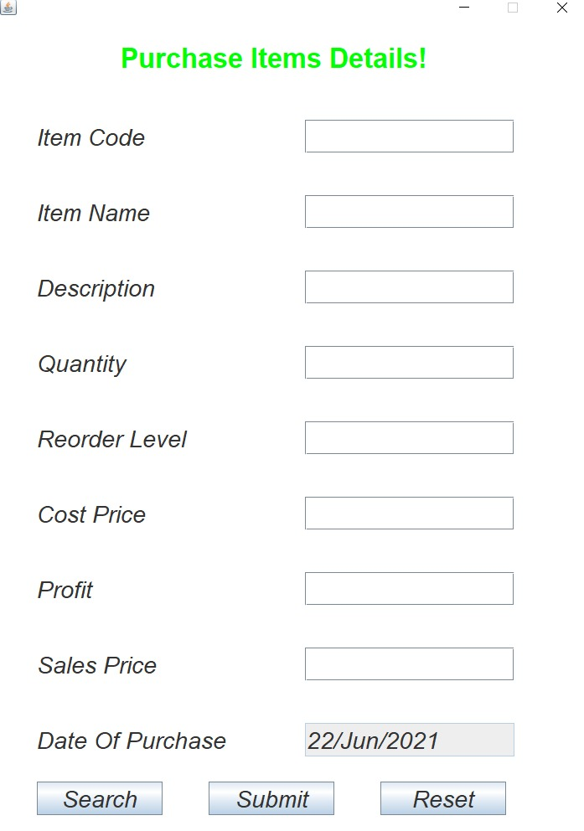

SALE ITEM

import java.awt.*;
import java.util.Date;
import java.awt.event.*;
import javax.swing.*;
import java.sql.*;
import javax.swing.table.*;
class Frame2 extends Frame implements ActionListener
{
JLabel jl=new JLabel("Bill Details!");
JLabel bl1=new JLabel("Bill No.");
JLabel bt1=new JLabel("");
JLabel bl2=new JLabel("Date");
JLabel bt2=new JLabel("");
JLabel bl3=new JLabel("Customer Name");
JLabel bt3=new JLabel("");
JLabel bl4=new JLabel("Mobile");
JLabel bt4=new JLabel("");
JLabel jtl=new JLabel("Item Details....");
JLabel bl5=new JLabel("Total Ammount");
JLabel bt5=new JLabel();
JButton b1=new JButton("Submit");
JButton b2=new JButton("Close");
Font fo=new Font("",1,33);
Font fn=new Font("",2,25);
Font ft=new Font("",1,22);
JTable t=new JTable();
DefaultTableModel model=new DefaultTableModel();
String head[]={"S_no","ItemName","Description","Sale Price","Quantity","Amt"};
String iname;
Frame2()
{
setLayout(null);
setSize(1000,1020);
setLocationRelativeTo(null);
setResizable(false);
setTitle("Stockz");
jl.setForeground(Color.GREEN);
jl.setBounds(400,50,3000,50);add(jl);
jl.setFont(fo);add(jl);
//bt1.setText();
bl1.setBounds(50,150,200,50);add(bl1);
bl1.setFont(fn);add(bl1);
bt1.setBounds(300,150,200,50);add(bt1);
bt1.setFont(fn);add(bt1);
bl2.setBounds(550,150,200,50);add(bl2);
bl2.setFont(fn);add(bl2);
bt2.setBounds(800,150,200,50);add(bt2);
bt2.setFont(fn);add(bt2);
bl3.setBounds(50,250,200,50);add(bl3);
bl3.setFont(fn);add(bl3);
bt3.setBounds(300,250,200,50);add(bt3);
bt3.setFont(fn);add(bt3);
bl4.setBounds(550,250,200,50);add(bl4);
bl4.setFont(fn);add(bl4);
bt4.setBounds(800,250,200,50);add(bt4);
bt4.setFont(fn);add(bt4);
jtl.setForeground(Color.GREEN);
jtl.setBounds(400,350,300,50);add(jtl);
jtl.setFont(fo);add(jtl);
model.setColumnIdentifiers(head);
t.setModel(model);
JTableHeader th=t.getTableHeader();
th.setFont(ft);
JScrollPane scr=new JScrollPane(t);
scr.setBounds(50,450,900,350);
add(scr);
bl5.setBounds(50,840,200,50);add(bl5);
bl5.setFont(fn);add(bl5);
bt5.setBounds(300,840,200,50);add(bt5);
bt5.setFont(fn);add(bt5);
b1.setBounds(315,930,150,50);add(b1);
b1.setFont(fn);add(b1);
b2.setBounds(500,930,150,50);add(b2);
b2.setFont(fn);add(b2);
b2.addActionListener(this);
}
public void actionPerformed(ActionEvent e)
{
if(e.getSource()==b2)
{
dispose();
}
}
}
class Frame1 extends Frame implements ActionListener
{
JLabel jl=new JLabel("Sale Details !");
JLabel l1=new JLabel("Date");
JLabel l2=new JLabel("Customer Name");
JLabel l3=new JLabel("Mobile");
JLabel l4=new JLabel("Item Code");
JLabel l5=new JLabel("Item Name");
JLabel l6=new JLabel("Description");
JLabel l7=new JLabel("Available Quantity");
JLabel l8=new JLabel("Saling Price");
JLabel l9=new JLabel("Quantity");
JTextField t1=new JTextField();
JTextField t2=new JTextField();
JTextField t3=new JTextField();
JTextField t4=new JTextField();
JTextField t5=new JTextField();
JTextField t6=new JTextField();
JTextField t7=new JTextField();
JTextField t8=new JTextField();
JTextField t9=new JTextField();
JButton b1=new JButton("Search");
JButton b2=new JButton("Add To Cart");
JButton b3=new JButton("Remove TO Cart");
JButton b4=new JButton("Bill Generation");
JButton b5=new JButton("Reset");
//JButton b5=new JButton("");
Font fo=new Font("",1,35);
Font fn=new Font("",2,30);
Font fb=new Font("",2,17);
Font ft=new Font("",1,20);
Date dd=new Date();
DefaultTableModel model=new DefaultTableModel();
JTable t=new JTable();
String head[]={"S_no","Item Name","Description","Saling Price","Quantity","Amount"};
Connection con;
PreparedStatement st;
ResultSet rs;
String icode,iname,idesc,dt;
int quty,pquty,srl=1;
float sp,amt;
Frame1()
{
setLayout(null);
setSize(1450,1000);
setLocationRelativeTo(null);
setResizable(false);
setTitle("Stockz");
addWindowListener(new WindowAdapter ()
{
public void windowClosing(WindowEvent ec)
{
System.exit(0);
}
});
jl.setForeground(Color.GREEN);
jl.setBounds(300,50,300,50);add(jl);
jl.setFont(fo);add(jl);
l1.setBounds(60,150,200,40);add(l1);
l1.setFont(fn);add(l1);
l2.setBounds(60,230,250,40);add(l2);
l2.setFont(fn);add(l2);
l3.setBounds(60,310,200,40);add(l3);
l3.setFont(fn);add(l3);
l4.setBounds(60,390,200,40);add(l4);
l4.setFont(fn);add(l4);
l5.setBounds(60,470,200,40);add(l5);
l5.setFont(fn);add(l5);
l6.setBounds(60,550,200,40);add(l6);
l6.setFont(fn);add(l6);
l7.setBounds(60,630,250,40);add(l7);
l7.setFont(fn);add(l7);
l8.setBounds(60,710,200,40);add(l8);
l8.setFont(fn);add(l8);
l9.setBounds(60,790,200,40);add(l9);
l9.setFont(fn);add(l9);
t1.setBounds(350,150,275,40);add(t1);
t1.setFont(fn);add(t1);
dt=String.valueOf(dd);
dt=dt.substring(8,10)+"/"+dt.substring(4,7)+"/"+dt.substring(24);
t1.setText(dt);
t1.setEditable(false);
t2.setBounds(350,230,275,40);add(t2);
t2.setFont(fn);add(t2);
t3.setBounds(350,310,275,40);add(t3);
t3.setFont(fn);add(t3);
t4.setBounds(350,390,275,40);add(t4);
t4.setFont(fn);add(t4);
t5.setBounds(350,470,275,40);add(t5);
t5.setFont(fn);add(t5);
t6.setBounds(350,550,275,40);add(t6);
t6.setFont(fn);add(t6);
t7.setBounds(350,630,275,40);add(t7);
t7.setFont(fn);add(t7);
t8.setBounds(350,710,275,40);add(t8);
t8.setFont(fn);add(t8);
t9.setBounds(350,790,275,40);add(t9);
t9.setFont(fn);add(t9);
b1.setBounds(50,860,120,40);add(b1);
b1.setFont(fb);add(b1);
b2.setBounds(180,860,130,40);add(b2);
b2.setFont(fb);add(b2);
b3.setBounds(320,860,160,40);add(b3);
b3.setFont(fb);add(b3);
b4.setBounds(490,860,150,40);add(b4);
b4.setFont(fb);add(b4);
b5.setBounds(650,860,130,40);add(b5);
b5.setFont(fb);add(b5);
model.setColumnIdentifiers(head);
t.setModel(model);
JTableHeader th=t.getTableHeader();
th.setFont(ft);
JScrollPane scr=new JScrollPane(t);
scr.setBounds(700,150,700,600);
add(scr);
try
{
Class.forName("com.mysql.jdbc.Driver");
con=DriverManager.getConnection("jdbc:mysql://localhost/bca","root","");
}
catch(Exception ec)
{
System.out.println(ec);
}
b1.addActionListener(this);
b2.addActionListener(this);
b3.addActionListener(this);
b4.addActionListener(this);
b5.addActionListener(this);
}
public void actionPerformed(ActionEvent e)
{

if(e.getSource()==b2)
{

quty=Integer.parseInt(t7.getText());
pquty=Integer.parseInt(t9.getText());
if(quty<pquty)
{
JOptionPane.showMessageDialog(null,"Available Quantity is less,So please enter the Quantity less than Available quantity ");
t9.setText("se");
t9.setText("");
t9.requestFocus();
}
else if(quty>=pquty)
{
iname=t5.getText();
idesc=t6.getText();
pquty=Integer.parseInt(t9.getText());
sp=Float.parseFloat(t8.getText());
amt=sp*pquty;
model.addRow(new Object[]{srl,iname,idesc,sp,pquty,amt});
/*t2.setText("se");
t2.setText("");
t3.setText("aw");
t3.setText("");
t4.setText("aq");
t4.setText("");
t5.setText("at");
t5.setText("");
t6.setText("ay");
t6.setText("");
t7.setText("au");
t7.setText("");
t8.setText("ai");
t8.setText("");
t9.setText("ao");
t9.setText("");*/
srl++;
}
}
else if(e.getSource()==b1)
{

icode=t4.getText();
try
{
st=con.prepareStatement("Select * from iteminfo where itemcode=?");
st.setString(1,icode);
rs=st.executeQuery();
if(rs.next())
{
iname=rs.getString("itemname");
idesc=rs.getString("itemdescription");
quty=rs.getInt("quantity");
sp=rs.getInt("saleprice");
t5.setText(iname);
t6.setText(idesc);
t7.setText(String.valueOf(quty));
t8.setText(String.valueOf(sp));
}
else
{
JOptionPane.showMessageDialog(null,"Ivalid ItemCode!");
}
}
catch(Exception re)
{
System.out.println(re);
}
}
else if(e.getSource()==b5)
{
t2.setText("se");
t2.setText("");
t3.setText("aw");
t3.setText("");
t4.setText("aq");
t4.setText("");
t5.setText("at");
t5.setText("");
t6.setText("ay");
t6.setText("");
t7.setText("au");
t7.setText("");
t8.setText("ai");
t8.setText("");
t9.setText("ao");
t9.setText("");

}
else if(e.getSource()==b4)
{
Frame2 f=new Frame2();
f.setVisible(true);
}
else if(e.getSource()==b3)
{
model.removeRow(t.getSelectedRow());
//model.setRowCount(0);
}
}
}
class Sale
{
public static void main(String args[])
{
Frame1 f=new Frame1();
f.setVisible(true);
}
}

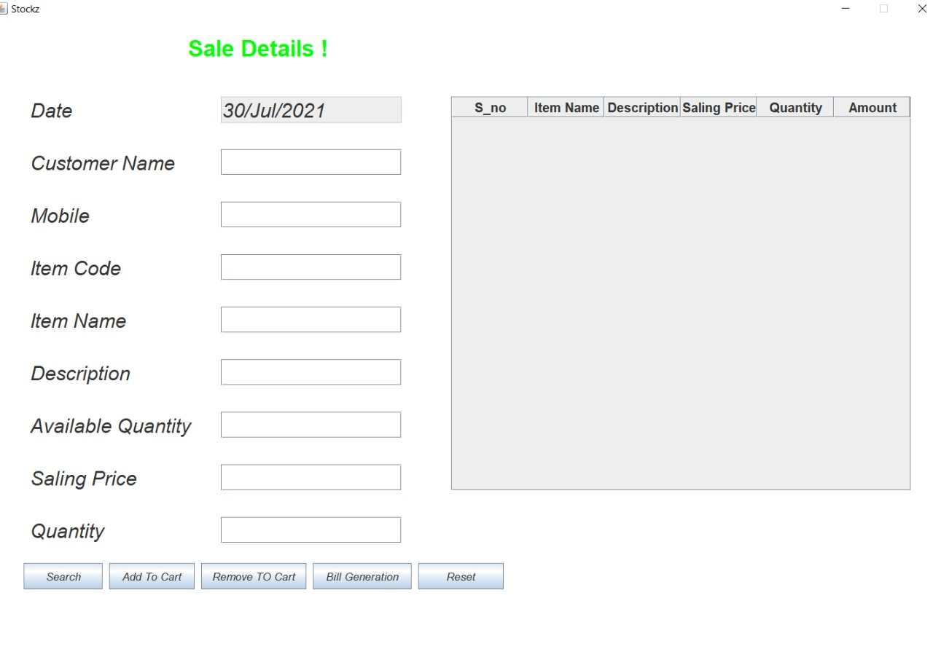
BILL

import java.awt.*;
import java.awt.event.*;
import javax.swing.*;
import java.sql.*;
import javax.swing.table.*;
class Frame1 extends Frame implements ActionListener
{
JLabel jl=new JLabel("Bill Details!");
JLabel bl1=new JLabel("Bill No.");
JLabel bt1=new JLabel("");
JLabel bl2=new JLabel("Date");
JLabel bt2=new JLabel("");
JLabel bl3=new JLabel("Customer Name");
JLabel bt3=new JLabel("");
JLabel bl4=new JLabel("Mobile");
JLabel bt4=new JLabel("");
JLabel jtl=new JLabel("Item Details....");
JLabel bl5=new JLabel("Total Ammount");
JLabel bt5=new JLabel();
JButton b=new JButton("Close");
Font fo=new Font("",1,33);
Font fn=new Font("",2,25);
Font ft=new Font("",1,22);
JTable t=new JTable();
DefaultTableModel model=new DefaultTableModel();
String head[]={"S_no","ItemName","Description","Sale Price","Quantity","Amt"};
Frame1()
{
setLayout(null);
setSize(1000,1020);
setLocationRelativeTo(null);
setResizable(false);
jl.setForeground(Color.GREEN);
jl.setBounds(400,50,3000,50);add(jl);
jl.setFont(fo);add(jl);
bl1.setBounds(50,150,200,50);add(bl1);
bl1.setFont(fn);add(bl1);
bt1.setBounds(300,150,200,50);add(bt1);
bt1.setFont(fn);add(bt1);
bl2.setBounds(550,150,200,50);add(bl2);
bl2.setFont(fn);add(bl2);
bt2.setBounds(800,150,200,50);add(bt2);
bt2.setFont(fn);add(bt2);
bl3.setBounds(50,250,200,50);add(bl3);
bl3.setFont(fn);add(bl3);
bt3.setBounds(300,250,200,50);add(bt3);
bt3.setFont(fn);add(bt3);
bl4.setBounds(550,250,200,50);add(bl4);
bl4.setFont(fn);add(bl4);
bt4.setBounds(800,250,200,50);add(bt4);
bt4.setFont(fn);add(bt4);
jtl.setForeground(Color.GREEN);
jtl.setBounds(400,350,300,50);add(jtl);
jtl.setFont(fo);add(jtl);
model.setColumnIdentifiers(head);
t.setModel(model);
JTableHeader th=t.getTableHeader();
th.setFont(ft);
JScrollPane scr=new JScrollPane(t);
scr.setBounds(50,450,900,350);
add(scr);
bl5.setBounds(50,840,200,50);add(bl5);
bl5.setFont(fn);add(bl5);
bt5.setBounds(300,840,200,50);add(bt5);
bt5.setFont(fn);add(bt5);
b.setBounds(400,930,150,50);add(b);
b.setFont(fn);add(b);
b.addActionListener(this);
}
public void actionPerformed(ActionEvent e)
{
if(e.getSource()==b)
{
dispose();
}
}
}
class Bill
{
public static void main(String args[])
{
Frame1 f=new Frame1();
f.setVisible(true);
}
}
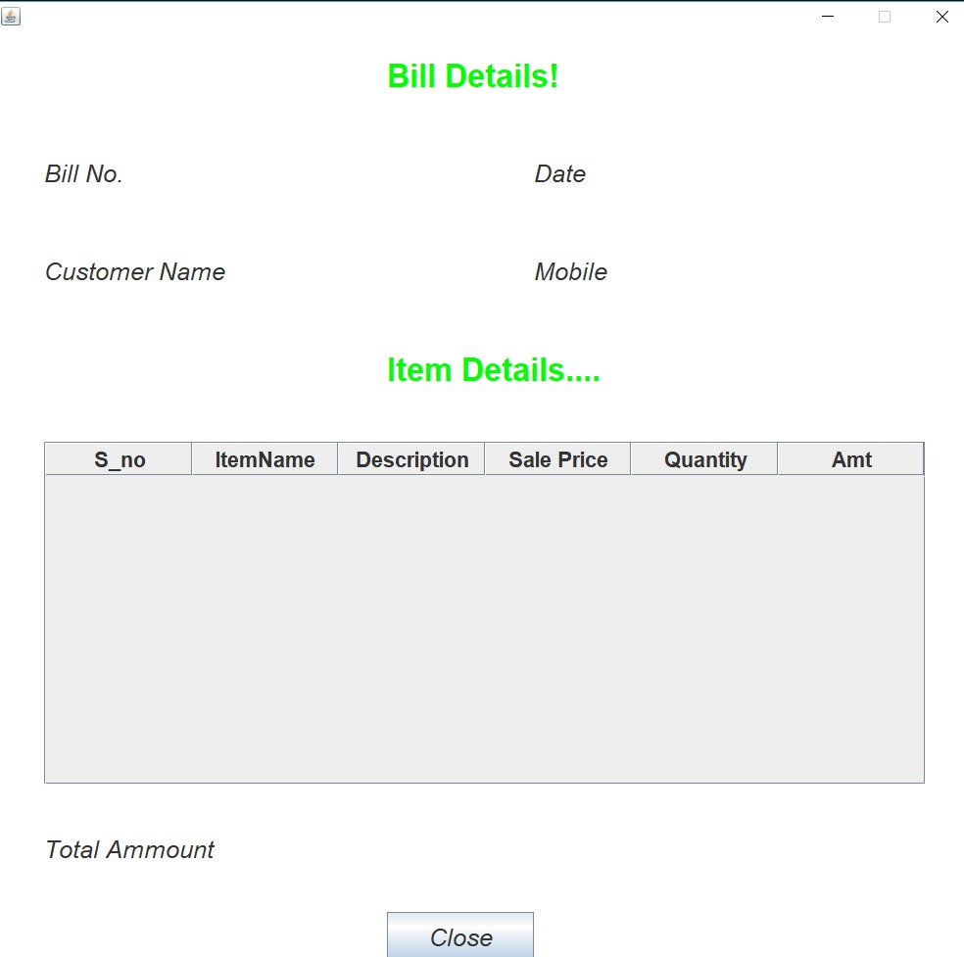

REPORT

ALL CUSTOMER DETAILS

import java.awt.*;
import javax.swing.*;
import java.awt.event.*;
import javax.swing.table.*;
import java.sql.*;

class CustomerDetails1 implements WindowListener
{
Frame f;
Label l1;
JTable jt;
DefaultTableModel model;
Connection con;
PreparedStatement st;
ResultSet rs;
int id,phoneno;
String nm,addr,shopname;

CustomerDetails1()
{
f=new Frame("Customer Details");
f.setSize(700,700);
f.setLocationRelativeTo(null);
f.setResizable(false);
f.setLayout(null);
f.setForeground(Color.GREEN);
f.addWindowListener(this);

Font f1=new Font("Arail",Font.BOLD,30);

l1=new Label("Customer Details");
l1.setFont(f1);
l1.setBounds(250,50,300,30);
f.add(l1);

String heads[]={"Customer ID","Name","Shop Name","Address","Phone No."};

model=new DefaultTableModel();
model.setColumnIdentifiers(heads);

jt=new JTable();
jt.setModel(model);

JScrollPane sc=new JScrollPane(jt);
sc.setBounds(80,130,540,500);
f.add(sc);

try
{
Class.forName("com.mysql.jdbc.Driver");
con=DriverManager.getConnection("jdbc:mysql://localhost/bca","root","");
st=con.prepareStatement("select * from custinfo");
rs=st.executeQuery();
while(rs.next())
{
id=rs.getInt(1);
nm=rs.getString(2);
shopname=rs.getString(3);
addr=rs.getString(4);
phoneno=rs.getInt(5);
model.addRow(new Object[]{id,nm,shopname,addr,phoneno});
}
}
catch(Exception e)
{
System.out.print(e);
}
f.setVisible(true);
}

public void windowOpened(WindowEvent we)
{
}

public void windowActivated(WindowEvent we)
{
}

public void windowDeactivated(WindowEvent we)
{
}

public void windowIconified(WindowEvent we)
{
}

public void windowDeiconified(WindowEvent we)
{
}

public void windowClosing(WindowEvent we)
{
System.exit(0);
}

public void windowClosed(WindowEvent we)
{
}
}

class CustomerDetails
{
public static void main(String[] s)
{
CustomerDetails1 cd=new CustomerDetails1();
}
}
}
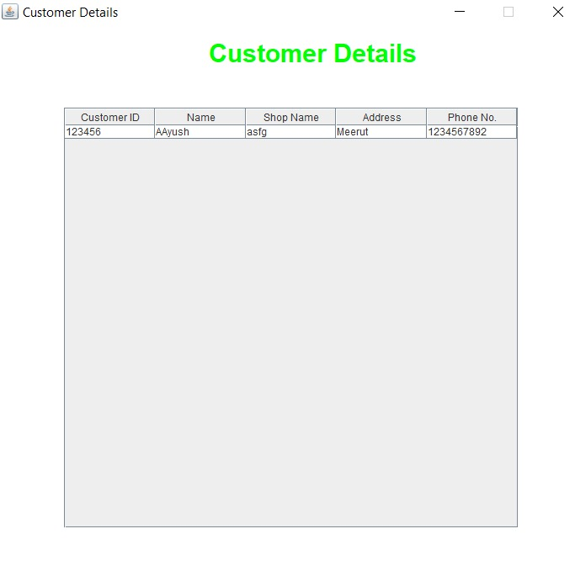
ALL EMPLOYEE DETAILS

import java.awt.*;
import javax.swing.*;
import java.awt.event.*;
import javax.swing.table.*;
import java.sql.*;

class EmployeeDetails1 implements WindowListener
{
Frame f;
Label l1;
JTable jt;
DefaultTableModel model;
Connection con;
PreparedStatement st;
ResultSet rs;
int salary;
String id,nm,addr,designation,email,dateofjoin,phoneno;
//Double salary;

EmployeeDetails1()
{
f=new Frame("Employee Details");
f.setSize(700,700);
f.setLocationRelativeTo(null);
f.setResizable(false);
f.setLayout(null);
f.setForeground(Color.GREEN);
f.addWindowListener(this);

Font f1=new Font("Arail",Font.BOLD,30);

l1=new Label("Employee Details");
l1.setFont(f1);
l1.setBounds(200,50,310,40);
f.add(l1);

String heads[]={"Employee ID","Name","Designation","Salary","Phone No.","Address","Email","Dateofjoin"};

model=new DefaultTableModel();
model.setColumnIdentifiers(heads);

jt=new JTable();
jt.setModel(model);

JScrollPane sc=new JScrollPane(jt);
sc.setBounds(80,130,540,500);
f.add(sc);

try
{
Class.forName("com.mysql.jdbc.Driver");
con=DriverManager.getConnection("jdbc:mysql://localhost/bca","root","");
st=con.prepareStatement("select * from empinfo");
rs=st.executeQuery();
while(rs.next())
{
id=rs.getString(1);
nm=rs.getString(2);
designation=rs.getString(3);
salary=rs.getInt(4);
phoneno=rs.getString(5);
addr=rs.getString(6);
email=rs.getString(7);
dateofjoin=rs.getString(8);
model.addRow(new Object[]{id,nm,designation,salary,phoneno,addr,email,dateofjoin});
}
}
catch(Exception e)
{
System.out.print(e);
}
f.setVisible(true);
}

public void windowOpened(WindowEvent we)
{
}

public void windowActivated(WindowEvent we)
{
}

public void windowDeactivated(WindowEvent we)
{
}

public void windowIconified(WindowEvent we)
{
}

public void windowDeiconified(WindowEvent we)
{
}

public void windowClosing(WindowEvent we)
{
System.exit(0);
}

public void windowClosed(WindowEvent we)
{
}
}

class EmployeeDetails
{
public static void main(String[] s)
{
EmployeeDetails1 cd=new EmployeeDetails1();
}
}

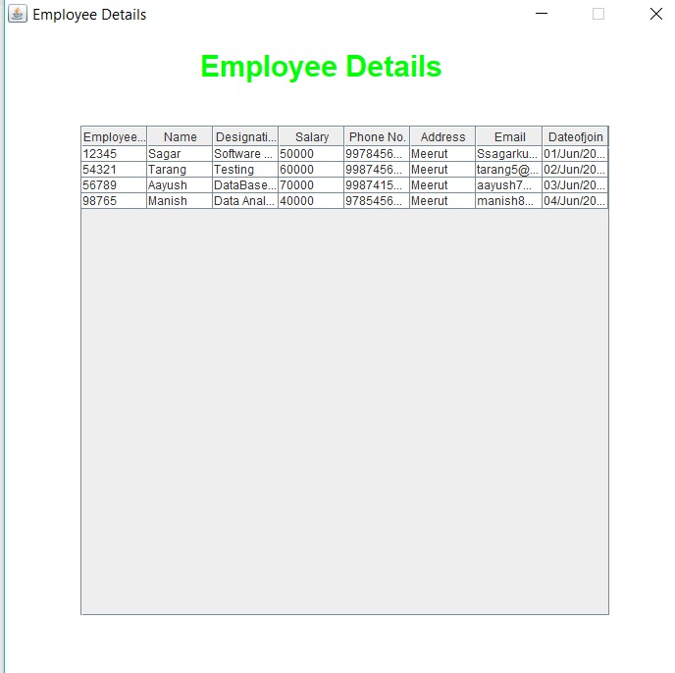

STOCK DETAILS

import java.awt.*;
import javax.swing.*;
import java.awt.event.*;
import javax.swing.table.*;
import java.sql.*;

class StockDetails1 implements WindowListener
{
Frame f;
Label l1;
JTable jt;
DefaultTableModel model;
Connection con;
PreparedStatement st;
ResultSet rs;
int quantity,reorderlevel;
String itemcode,itemname,itemdescription,date;
Float costprice,profit,saleprice;

StockDetails1()
{
f=new Frame("Stock Details");
f.setSize(700,700);
f.setLocationRelativeTo(null);
f.setResizable(false);
f.setLayout(null);
f.setForeground(Color.GREEN);
f.addWindowListener(this);

Font f1=new Font("Arail",Font.BOLD,30);

l1=new Label("Stock Details");
l1.setFont(f1);
l1.setBounds(250,50,300,40);
f.add(l1);

String heads[]={"Item Code","Item Name","Item Description","Quantity","Reorder Level","Cost Price","Profit","Sale Price","Date"};

model=new DefaultTableModel();
model.setColumnIdentifiers(heads);

jt=new JTable();
jt.setModel(model);

JScrollPane sc=new JScrollPane(jt);
sc.setBounds(80,130,540,500);
f.add(sc);

try
{
Class.forName("com.mysql.jdbc.Driver");
con=DriverManager.getConnection("jdbc:mysql://localhost/bca","root","");
st=con.prepareStatement("select * from iteminfo");
rs=st.executeQuery();
while(rs.next())
{
itemcode=rs.getString(1);
itemname=rs.getString(2);
itemdescription=rs.getString(3);
quantity=rs.getInt(4);
reorderlevel=rs.getInt(5);
costprice=rs.getFloat(6);
profit=rs.getFloat(7);
saleprice=rs.getFloat(8);
date=rs.getString(9);
model.addRow(new Object[]{itemcode,itemname,itemdescription,quantity,reorderlevel,costprice,profit,saleprice,date});
}
}
catch(Exception e)
{
System.out.print(e);
}
f.setVisible(true);
}

public void windowOpened(WindowEvent we)
{
}

public void windowActivated(WindowEvent we)
{
}

public void windowDeactivated(WindowEvent we)
{
}

public void windowIconified(WindowEvent we)
{
}

public void windowDeiconified(WindowEvent we)
{
}

public void windowClosing(WindowEvent we)
{
System.exit(0);
}

public void windowClosed(WindowEvent we)
{
}
}

class StockDetails
{
public static void main(String[] s)
{
StockDetails1 cd=new StockDetails1();
}
}
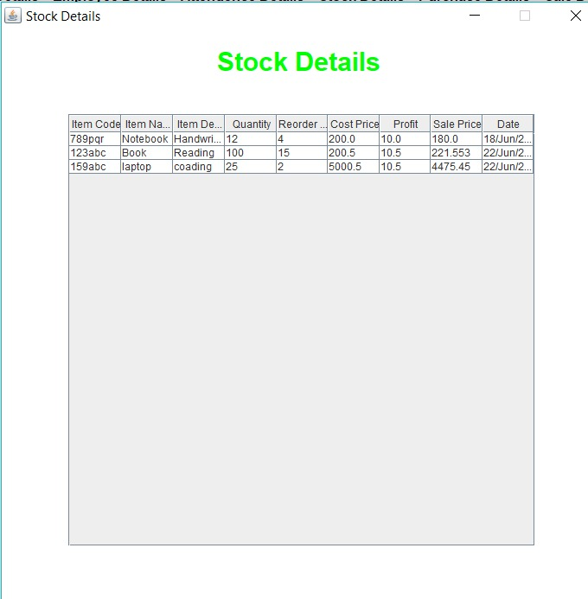
PURCHAS DETAILS

import java.awt.*;
import javax.swing.*;
import java.awt.event.*;
import javax.swing.table.*;
import java.sql.*;

class PurchaseDetails1 implements WindowListener
{
Frame f;
Label l1;
JTable jt;
DefaultTableModel model;
Connection con;
PreparedStatement st;
ResultSet rs;
int quantity;
String itemcode,dateofpurchase;
Float costprice,profit,saleprice;

PurchaseDetails1()
{
f=new Frame("Purchase Details");
f.setSize(700,700);
f.setLocationRelativeTo(null);
f.setResizable(false);
f.setLayout(null);
f.setForeground(Color.GREEN);
f.addWindowListener(this);

Font f1=new Font("Arail",Font.BOLD,30);

l1=new Label("Purchase Details");
l1.setFont(f1);
l1.setBounds(150,50,300,30);
f.add(l1);

String heads[]={"Item Code","Quantity","Cost Price","Profit","Sale Price","Date of Purchase"};

model=new DefaultTableModel();
model.setColumnIdentifiers(heads);

jt=new JTable();
jt.setModel(model);

JScrollPane sc=new JScrollPane(jt);
sc.setBounds(80,130,540,500);
f.add(sc);

try
{
Class.forName("com.mysql.jdbc.Driver");
con=DriverManager.getConnection("jdbc:mysql://localhost/bca","root","");
st=con.prepareStatement("select * from purchase");
rs=st.executeQuery();
while(rs.next())
{
itemcode=rs.getString(1);
quantity=rs.getInt(2);
costprice=rs.getFloat(3);
profit=rs.getFloat(4);
saleprice=rs.getFloat(5);
dateofpurchase=rs.getString(6);
model.addRow(new Object[]{itemcode,quantity,costprice,profit,saleprice,dateofpurchase});
}
}
catch(Exception e)
{
System.out.print(e);
}
f.setVisible(true);
}

public void windowOpened(WindowEvent we)
{
}

public void windowActivated(WindowEvent we)
{
}

public void windowDeactivated(WindowEvent we)
{
}

public void windowIconified(WindowEvent we)
{
}

public void windowDeiconified(WindowEvent we)
{
}

public void windowClosing(WindowEvent we)
{
System.exit(0);
}

public void windowClosed(WindowEvent we)
{
}
}

class PurchaseDetails
{
public static void main(String[] s)
{
PurchaseDetails1 cd=new PurchaseDetails1();
}
}
SALES DETAILS

import java.awt.*;
import javax.swing.*;
import java.awt.event.*;
import javax.swing.table.*;
import java.sql.*;

class SaleDetails1 implements WindowListener
{
Frame f;
Label l1;
JTable jt;
DefaultTableModel model;
Connection con;
PreparedStatement st;
ResultSet rs;
int quantity;
String itemcode,itemname,description,date,customername,mobile;

SaleDetails1()
{
f=new Frame("Sale Details");
f.setSize(700,700);
f.setLocationRelativeTo(null);
f.setResizable(false);
f.setLayout(null);
f.setForeground(Color.GREEN);
f.addWindowListener(this);

Font f1=new Font("Arail",Font.BOLD,30);

l1=new Label("Sale Details");
l1.setFont(f1);
l1.setBounds(250,50,310,40);
f.add(l1);

String heads[]={"Date","Customer Name","Mobile","Item Code","Item Name","Description","Quantity"};

model=new DefaultTableModel();
model.setColumnIdentifiers(heads);

jt=new JTable();
jt.setModel(model);

JScrollPane sc=new JScrollPane(jt);
sc.setBounds(80,130,540,500);
f.add(sc);

try
{
Class.forName("com.mysql.jdbc.Driver");
con=DriverManager.getConnection("jdbc:mysql://localhost/bca","root","");
st=con.prepareStatement("select * from sale");
rs=st.executeQuery();
while(rs.next())
{
date=rs.getString(1);
customername=rs.getString(2);
mobile=rs.getString(3);
itemcode=rs.getString(4);
itemname=rs.getString(5);
description=rs.getString(6);
quantity=rs.getInt(7);
model.addRow(new Object[]{date,customername,mobile,itemcode,itemname,description,quantity});
}
}
catch(Exception e)
{
System.out.print(e);
}
f.setVisible(true);
}

public void windowOpened(WindowEvent we)
{
}

public void windowActivated(WindowEvent we)
{
}

public void windowDeactivated(WindowEvent we)
{
}

public void windowIconified(WindowEvent we)
{
}

public void windowDeiconified(WindowEvent we)
{
}

public void windowClosing(WindowEvent we)
{
System.exit(0);
}

public void windowClosed(WindowEvent we)
{
}
}

class SaleDetails
{
public static void main(String[] s)
{
SaleDetails1 cd=new SaleDetails1();
}
}

